RETAIL MANAGEMENT PLATFORM WITH INTELLIGENT STOCK MONITORING AND PERSONALIZED SYSTEM FOR YOPHIE PC PRODUCT RECOMMENDATION COMPUTER TRADING

A Capstone Project Presented to the Faculty, College of Computer Studies
Laguna State Polytechnic University
Los Baños Campus
Los Baños, Laguna

In Partial Fulfillment of the Requirements for the Degree
Bachelor of Science in Information Technology
Specialized in Service Management Program

SAMSON G. ABNAY

JOCELYN O. PADALLAN

June 2026
APPROVAL SHEET

The The Capstone Project entitled “RETAIL MANAGEMENT PLATFORM WITH INTELLIGENT STOCK MONITORING AND PERSONALIZED PRODUCT RECOMMENDATION SYSTEM FOR YOPHIE PC COMPUTER TRADING”, prepared and submitted by Samson G. Abnay in partial fulfillment of the requirements for the degree Bachelor of Science in Information Technology specialized in Service Management Program, is hereby recommended for approval and acceptance.

JOCELYN O. PADALLAN
Adviser

Approved and Accepted by the Committee on Oral Examination with a grade of _______.

MYRA V. PAICAGLINO SHERWIN B. SAPIN
Member Member

JEFFERSON L. LERIOS
Member

Accepted in partial fulfillment of the requirements for the degree of Bachelor of Science in Information Technology specialized in Service Management Program.

LOYD S. ECHALAR, DIT
Associate Dean, College of Computer Studies

OFELIA B. MANINGAS, Ed. D. ___________
Chairperson, Research and Development Services Date Signed

RESEARCH CONTRIBUTION NO.
ACKNOWLEDGMENT

The researcher would like to express my deepest gratitude to Almighty God for granting me the wisdom, strength, and perseverance needed to complete this capstone project. His guidance has been my foundation throughout this journey.
And also extend my heartfelt appreciation to my family for their unwavering love, patience, understanding, and continuous encouragement. Their support has consistently motivated me to move forward and inspired me to give my best at every stage of this study.
This work is wholeheartedly dedicated to the individuals who supported me throughout the development of the Retail Management Platform with Intelligent Stock Monitoring and Personalized Product Recommendation System for Yophie PC Computer Trading. To William Daryl Limpiada and Joyce Rachel Limpiada, thank you for your constant encouragement, understanding, and unwavering belief in my abilities. Your support whether through motivation, patience, or providing the time and space I needed to work played an essential role in the success of this project.
Deepest appreciation to Ms. Joanne Bustamante and Mr. William Howard Limpiada, whose kindness, guidance, and generosity have greatly contributed to this endeavor. Thank you for offering comfort, assistance, and a peaceful environment that allowed me to stay focused and determined. Your thoughtful advice, emotional support, and financial help were invaluable throughout this journey. This project stands as a reflection of your love, dedication, and unwavering support, for which I am sincerely grateful.
I sincerely thank my adviser, Ms. Jocelyn O. Padallan, for her guidance, insightful feedback, and encouragement that shaped and strengthened this study. I am also grateful to the Faculty of the College of Computer Studies, Laguna State Polytechnic University, Los Baños Campus, for the knowledge, skills, and academic foundation they have provided.
Finally, I would like to express my special appreciation to Mr. and Mrs. Limpiada, owners of Yophie PC Computer Trading in Calamba City, Laguna, for their trust, cooperation, and willingness to test and implement the system. Their support allowed this project to achieve real-world relevance and practical value.
THE RESEARCHER

DEDICATION

To This humble work is lovingly dedicated to the individuals who stood beside me throughout my academic journey.
To my parents and family, thank you for your unwavering love, sacrifices, and encouragement. Your belief in me gave me the strength to continue, even in the most challenging moments. This achievement is as much yours as it is mine.
To my mentors and professors, I extend my deepest gratitude for your guidance, knowledge, and support. Your lessons have shaped me not only as a student but also as an individual ready to face the demands of the real world.
To myself, I offer this acknowledgment wholeheartedly. As the sole researcher, I endured every challenge, late night, revision, and setback on my own yet I never gave up. This study stands as a testament to my perseverance, hard work, and determination. I am proud of the dedication I invested in completing this research independently.
Above all, to Almighty God, my source of wisdom, strength, and courage, thank you for your constant guidance. Without Your grace and blessing, this accomplishment would not have been possible.
S.G.A

ABSTRACT

This study was developed to help Yophie PC Computer Trading address the challenges of maintaining accurate inventory records and assisting customers in selecting compatible computer components. Manual monitoring of stocks and inconsistent recording of item movements often result in inventory discrepancies, stockouts, and delays in decision-making. To respond to this problem, a web-based retail management platform was designed featuring automated stock monitoring, transaction recording, and product catalog management. The system processes inventory activities such as stock-in, stock-out, and adjustments, ensuring that stock levels are updated automatically in real time to reduce human error. A personalized product recommendation module was also integrated using predefined compatibility rules and product attributes to suggest relevant items based on customer needs and component specifications. The platform includes an interactive dashboard that displays stock status, low-stock alerts, product performance, and system notifications to support faster and more informed retail decisions. The system was tested for actual deployment readiness and was evaluated using the Technology Acceptance Model (TAM) and ISO 25010 software quality standards. Findings shows that the system is functional, reliable, and highly acceptable to users, demonstrating strong maintainability and performance efficiency. Additionally, the platform reduces manual tracking by providing automated inventory updates and transaction transparency, helping staff save time while minimizing inventory-related mistakes. Its recommendation feature improves customer experience by guiding buyers toward compatible and suitable products, supporting better purchasing decisions. The implementation further proves that integrating automated monitoring and intelligent recommendation techniques can enhance retail operations and improve overall business efficiency. Furthermore, the study highlights the practicality of adopting technology-driven systems in local retail environments, offering a reliable tool for inventory control and customer engagement. Through these innovations, the system supports improved retail management practices and contributes to the broader goal of creating more efficient and customer-centered retail businesses.

Keywords: Retail Management Platform, Intelligent Stock Monitoring, Inventory Discrepancy Prevention, Personalized Product Recommendation, Compatibility-Based Recommendation, Rule-Based Engine, Real-Time Inventory Updates

TABLE OF CONTENTS
Preliminaries Page
Title Page i
Approval Sheet ii
Acknowledgement iii
Dedication v
Abstract vi
Table of Contents vii
List of Figures ix
List of Tables x
Definition of Terms xii

CHAPTER
I INTRODUCTION
Project Context 1
Project Objective 4
Project Purpose 5
Scope and Limitation 6
Conceptual Framework 10

II REVIEW OF RELATED LITERATURE AND STUDIES
Related Literatures 11
Synthesis and Relevance of the Studies 24
Literature Matrix 25

III METHODOLOGY
Project Design 26
System Architecture 28
Evolutionary Prototyping Model 28
Project Locale 31
Model Development 33
Software Development 36
Materials 36
Software 39
Project Development 40
Agile Scrum Methodology 41
Scope 41
Design 41
Product Backlogs 43
Sprint Planning for Admin 46
Sprint Planning for Main Product 47
Daily Scrum 48
Sprint Execution 48
Sprint Review 49
Sprint Retrospective 49
Project Testing and Evaluation 50
Software Testing 50
Unit Testing 52
Integration Testing 53
Acceptance Testing 53
System Flowchart 53
Use Case Diagram 55
Evaluation Procedure 57
Population of the Study 58
Data Collection Instrument 60

IV RESULTS AND DISCUSSIONS

V SUMMARY, CONCLUSION, AND RECOMMENDATIONS

REFERENCES
APPENDICES A

LIST OF FIGURES

No. Title Page
1 Conceptual Framework 10
2 System Architecture 28
3 Evolutionary Prototyping Model 31
4 Owner of Yophie PC Computer Trading 32
5 Retail Management Platform Model 35
6 Agile Scrum Methodology 41
7 Levels of Testing 51
8 Unit Testing 52
9 Integration Testing 52
10 User Acceptance Testing 53
11 System Flowchart of Administrator 54
12 System Flowchart of Staff 54
13 System Flowchart of User 55
14 Use Case Diagram for Administrator 56
15 Use Case Diagram for Staff 56
16 Use Case Diagram for User 57
17 Quality Characteristics of ISO 25010 Standard 58
18 Administrator Dashboard 62
19 Product Table 63
20 Update Product 64
21 Add Product 64
22 Product Compatibility Matrix 65

LIST OF TABLES

No. Title Page
1 Literature Matrix 25
2 Hardware Requirements Used for Laptop/Computer 40
3 Product Backlog for Admin 44
4 Main Product Backlog (General Features) 45
5 Sprint Planning for Admin Feature 46
6 Sprint Planning for Main Product 47
7 Respondents of the Research Project 59
8 Quality Factor based on Respondents’ Response 67
9 Perceived of Ease Use based on Respondents’ Response 68
10 Perceived of Usefulness based on Respondent’s Response 69
11 Attitude Towards Using based on Respondents’ Response 70
12 Behavioral Intention to Use based on Respondents Response 71
13 Experience based on Respondents’ Response 72
14 Result of Technology Acceptance Model based on Response 73
15 Functional Suitability based on IT Specialist Response 74
16 Reliability based on IT Specialist Response 75
17 Performance Efficiency on IT Specialist Response 76
18 Operability on IT Specialist Response 77
19 Security on IT Specialist Response 78
20 Compatibility on IT Specialist Response 79
21 Maintainability on IT Specialist Response 79
22 Result of ISO 25010 based on IT Specialist Response 80
23 Unit Testing for Retail Management Platform 81
24 Integration Testing Result Retail Management Platform 82
25 Stress Testing Result for Retail Management Platform 83

API (Application Programming Interface)  DEFINITION OF TERMS |  | A communication layer that allows the frontend and backend systems to exchange data securely.
Automated Stock Monitoring |  | Refers to the system’s capability to automatically track, update, and record product quantities in real time without manual encoding.
Backend Processing |  | The behind-the-scenes logic that manages data storage, business rules, inventory updates, and recommendations.
Compatibility-Based Recommendation |  | A rule-based approach for suggesting computer parts that are technically compatible (e.g., CPU, motherboard).
Customer Activity Tracking |  | A background process that records customer browsing behavior to improve product suggestions.
Dashboard Analytics |  | Visual summaries of key business indicators such as stock levels, product performance, and transaction trends.
Inventory Discrepancy |  | A mismatch between the actual stock count and the recorded inventory level in the system.
Inventory Management |  | The process of organizing, tracking, and updating product quantities to maintain accurate stock records.
Laravel Framework |  | A PHP-based backend framework responsible for processing business logic, authentication, and API operations.
Low-Stock Notification |  | A real-time alert generated by the system when inventory levels drop below the minimum threshold.
MySQL Database |  | A relational database system used for storing inventory, user, and transaction records.
Notification and Alerts Module |  | A feature that informs administrators of important system events such as low inventory or system inconsistencies.
Personalized Product Recommendation |  | A system feature that generates product suggestions tailored to customer needs, preferences, and compatibility rules.
Product Attributes |  | Technical details such as model, generation, socket type, brand, and specifications used in product matching.
Product Catalog  Product Recommendation Module  Real-Time Updates  Rule-Based Engine  Stock-In and Stock-Out  Transaction Log  User Authentication Module  User Interface (UI)  Vue 3 Framework |  | A structured digital listing that contains detailed product information, including specifications, categories, and images.  The section of the system responsible for generating relevant and compatible product suggestions.  Instant changes in system data that reflect inventory modifications or user interactions without delay.  A recommendation mechanism that uses predefined logical rules to match products based on compatibility.  Inventory transactions that add to (stock-in) or deduct from (stock-out) the store’s product quantities.  A chronological record of all inventory and sales-related activities stored for auditing and review.  A system component that validates user credentials and controls access permissions.  The visual layout and interactive elements that users engage with to operate the system.  A modern JavaScript framework used to build the system’s interactive and responsive user interface.

CHAPTER 1

INTRODUCTION
Project Context

Retail management and stock monitoring are essential components of efficient operations in computer hardware businesses such as Yophie PC Computer Trading. The store has long served customers by providing computer hardware products and technical support; however, its initial reliance on manual processes became increasingly problematic as customer demand and product variety grew. Manual inventory tracking often resulted in errors, delays, and inaccurate stock records, particularly as inventory lists expanded (Madamidola, Daramola, Akintola, & Adeboje, 2024). Similarly, meeting rising customer expectations became more challenging when staff were required to manually check product availability, leading to slower service and reduced efficiency (Hagen, Spierings, Weltevreden, Risselada, & Atzema, 2023). In addition, manual product recommendation practices lacked accuracy and consistency, limiting the ability to guide customers effectively in selecting compatible computer components (Hussien, Rahma, & Abdul Wahab, 2021). As the business continued to grow, these challenges emphasized the need for a more efficient, automated, and technology-driven retail management approach.
These challenges are not unique to Yophie PC Computer Trading. Many small to medium sized retail businesses face operational inefficiencies due to manual inventory and recommendation processes. When inventory monitoring relies solely on spreadsheets and employee familiarity with stock, errors such as mismatches, delayed updates, and lost sales opportunities become common. Such inaccuracies disrupt daily operations and negatively impact customer satisfaction, particularly when clients expect fast and reliable service. Manual recommendation practices are equally inconsistent because suggestions depend heavily on employee experience and workload. Consequently, businesses risk falling behind competitors that already utilize automated and data-driven technologies to improve service quality and operational reliability.
To address these recurring issues, the proposed project introduces the Retail Management Platform with Intelligent Stock Monitoring and Personalized Product Recommendation System for Yophie PC Computer Trading. This system integrates automated inventory tracking with intelligent recommendation technology to streamline store operations. It continuously monitors stock levels, records sales transactions, and analyzes product data to suggest suitable items to customers. By automating these processes, the platform aims to minimize human error, reduce operational delays, and ensure that customers receive accurate and personalized recommendations. Ultimately, the goal is to provide a modernized system that supports efficient, timely, and structured retail operations.
Recent technological advancements further demonstrate the importance of adopting such systems. Global studies emphasize that inventory automation and AI-powered recommendation engines significantly enhance business productivity, decision-making, and customer engagement. Research shows that AI-driven recommendation engines play a crucial role in improving the accuracy and personalization of product suggestions, which strengthens customer interaction and satisfaction (Salunke & Nichite, 2022). Likewise, automated inventory systems have been found to reduce operational inconsistencies, improve tracking accuracy, and support real-time business decisions, making retail operations more efficient and responsive (Ugbebor, Adeteye, & Ugbebor, 2024). These innovations streamline workflows, minimize human error, and create a more predictable and adaptive business environment. As more computer retail shops worldwide adopt intelligent retail platforms, the shift toward automated solutions has become increasingly essential for maintaining competitive performance.
This trend is also evident in Philippine research, which highlights the effectiveness of web-based inventory systems and e-commerce platforms in improving accuracy, service delivery, and user satisfaction. Local evaluations consistently shows that digital solutions help small enterprises reduce manual workload, organize records efficiently, and optimize routine transactions. These findings reinforce the transformative potential of automated platforms in modernizing traditional retail practices within the country.
By developing and implementing the proposed Retail Management Platform with Intelligent Stock Monitoring and Personalized Product Recommendation System, this project aims to reduce operational inefficiencies, enhance service quality, and support sustainable business growth for Yophie PC Computer Trading. Through improved decision-making, accurate inventory management, and intelligent product recommendations, the system seeks to elevate customer experience, strengthen competitiveness, and close the technological gap that currently limits the business.

Project Objectives
This capstone project aimed to develop an integrated retail management system that addressed the operational needs of Yophie PC Computer Trading. By combining automated inventory monitoring with an intelligent product recommendation feature, the platform was designed to enhance efficiency, accuracy, and responsiveness in daily operations. Real-time stock tracking, automated updates, and compatibility-based suggestions helped reduce manual tasks, minimize errors, and support better decision-making. Overall, the system sought to improve inventory accuracy, streamline retail processes, and provide a better experience for both staff and customers. The following objectives outlined the key functions and goals of the proposed system.
1. To design a system that provides accurate, real-time stock monitoring to prevent inventory discrepancies.
2. To develop a product recommendation feature that generates personalized suggestions based on customer needs and preferences.
3. To test and evaluate the system using Technology Acceptance Model and ISO 25010 software product standards to verify its efficacy and quality.
Project Purpose
This study was significant because it addressed the operational challenges in managing inventory and providing product recommendations at Yophie PC Computer Trading. It greatly benefited the following:

For the Business Owner. The system enhanced operational workflow, reduced manual workload, improved inventory accuracy, and supported better sales decision-making.
For Customers. Customers received more accurate product information, faster service, and personalized recommendations that helped them choose the most suitable device for their needs.
For Employees. The platform minimized human errors and simplified inventory monitoring, allowing staff to focus on customer service and technical support.
For Future Researchers. This study served as a reference for developing smart platforms that integrated automated inventory systems with recommendation features.
For the ICT Community. The project demonstrated the value of automation and intelligent decision-support systems in small-to-medium retail operations.
Scope and Limitation
This project focused on developing a Retail Management Platform with Intelligent Stock Monitoring and Personalized Product Recommendation System for Yophie PC Computer Trading. It aimed to explore how a web-based system could support both customers and store personnel by providing a smarter way to browse products, compare specifications, and view detailed item information. The platform included features that automatically tracked stock levels, recorded product movements, and updated inventory quantities, helping staff maintain accurate records with less manual effort. Customers also benefited from a recommendation feature that suggested suitable items based on their needs and preferences, thereby providing a more guided shopping experience. By integrating these functions into a single online platform, the project sought to improve operational efficiency, enhance customer engagement, and streamline product management within the business.
Despite the successful development of the system, several limitations were acknowledged. The platform was designed specifically for the operational workflow of Yophie PC Computer Trading; therefore, its structure and processes might not have been readily applicable to other retail businesses without customization. In addition, the system did not support a complete e-commerce transaction process such as online checkout and payment integration, since the study primarily focused on product browsing, inventory monitoring, and recommendation features. The recommendation module also relied on predefined compatibility rules and encoded product attributes; thus, advanced AI-driven personalization based on customer behavior and purchasing patterns was not included within the scope of the study. Moreover, the accuracy of the inventory monitoring feature depended heavily on the correctness of the initial product data and transaction entries recorded by store personnel, and encoding errors could have affected the reliability of stock updates. Lastly, because the platform was web-based and operated entirely online, stable internet connectivity was required to ensure continuous access and functionality, which could have limited usability in areas with unstable or unavailable internet service.
User Authentication Module. The User Authentication Module served as the primary security gateway of the system, ensuring that only authorized personnel could access the Retail Management Platform. Users were required to enter their registered account credentials before accessing the dashboard. This module managed login validation, prevented unauthorized access, and protected sensitive business data. It also provided options for updating account information, resetting passwords, and managing user roles, ensuring a secure and controlled environment for system operations.
Dashboard Module. The Dashboard Module functioned as the system’s main interface, offering users a clear and organized overview of essential retail data. It displayed key information such as current stock levels, low-stock alerts, top-viewed products, and system-generated recommendations. Visual charts and summary cards helped administrators and staff understand inventory trends and product performance more easily. By presenting vital information in a user-friendly format, this module allowed faster decision-making and efficient monitoring of business operations.
Inventory Management Module. The Inventory Management Module handled the tracking and updating of product stocks. Users were able to add new inventory records, update quantities, record stock-in and stock-out transactions, and supervise item adjustments. The module helped reduce human error by automating quantity updates whenever a transaction was logged. It also maintained a detailed history of inventory activities, allowing administrators to review past records, identify discrepancies, and make informed decisions regarding replenishment and stocking needs.
Product Catalog and Details Module. The Product Catalog and Details Module organized and displayed all available items in the store. Customers and staff were able to browse through product listings, filter by category, compare specifications, and view detailed descriptions, images, and pricing. This module ensured that users accessed complete and accurate product information, supporting both customer decision-making and store personnel in responding to inquiries. It also helped maintain consistent and updated product data across the system.
Product Recommendation Module. The Product Recommendation Module enhanced the shopping experience by suggesting items based on user preferences, browsing behavior, and predefined matching rules. It provided personalized recommendations such as related products, similar items, and best-selling alternatives. Although not AI-driven at this stage, the module still guided customers toward suitable choices, simplified product selection, and supported sales improvement by promoting relevant items within the platform.
Transaction and Records Module. The Transaction and Records Module kept track of important business activities such as stock updates, item movements, and inventory adjustments. It provided a complete history of all recorded transactions, including dates, product names, quantity changes, and responsible personnel. This module ensured transparency, helped identify inconsistencies, and supported administrative tasks such as auditing, reporting, and inventory reconciliation.

Notifications and Alerts Module. The Notifications and Alerts Module acted as the system’s real-time alert center. It notified administrators when stock levels fell below the required threshold, when inconsistencies were detected, or when updates needed immediate attention. These alerts were displayed prominently on the dashboard to ensure quick response. This module helped prevent stockouts, improved operational readiness, and ensured that inventory records remained accurate and up-to-date.
Settings and Configuration Module. The Settings and Configuration Module allowed administrators to manage various system preferences and operational settings. Users were able to modify notification thresholds, update user roles, configure accessible modules, and adjust product categories or attributes. This module ensured that the platform remained adaptable to changing business needs while maintaining a secure and organized environment for store operations.
Conceptual Framework
The conceptual framework shows how the system combines inputs, processes, and outputs to enhance effective retail operations for Yophie PC Computer Trading. Product details, inventory data, user preferences, consumer behavior, and admin credentials are fed into the system as inputs. These undergo data validation, automated inventory tracking, rule-based compatibility checks, tailored recommendation creation, record modifications, and system notifications.

The system generates outputs like up-to-date inventory status, tailored product suggestions, low-stock notifications, sales and inventory analytics, and secure user authentication. A constant feedback cycle refreshes inventory logs and user engagement data, aiding in improving future suggestions and ensuring system precision. The framework illustrates how automation and data handling improve inventory management, decision-making, and the customer experience.
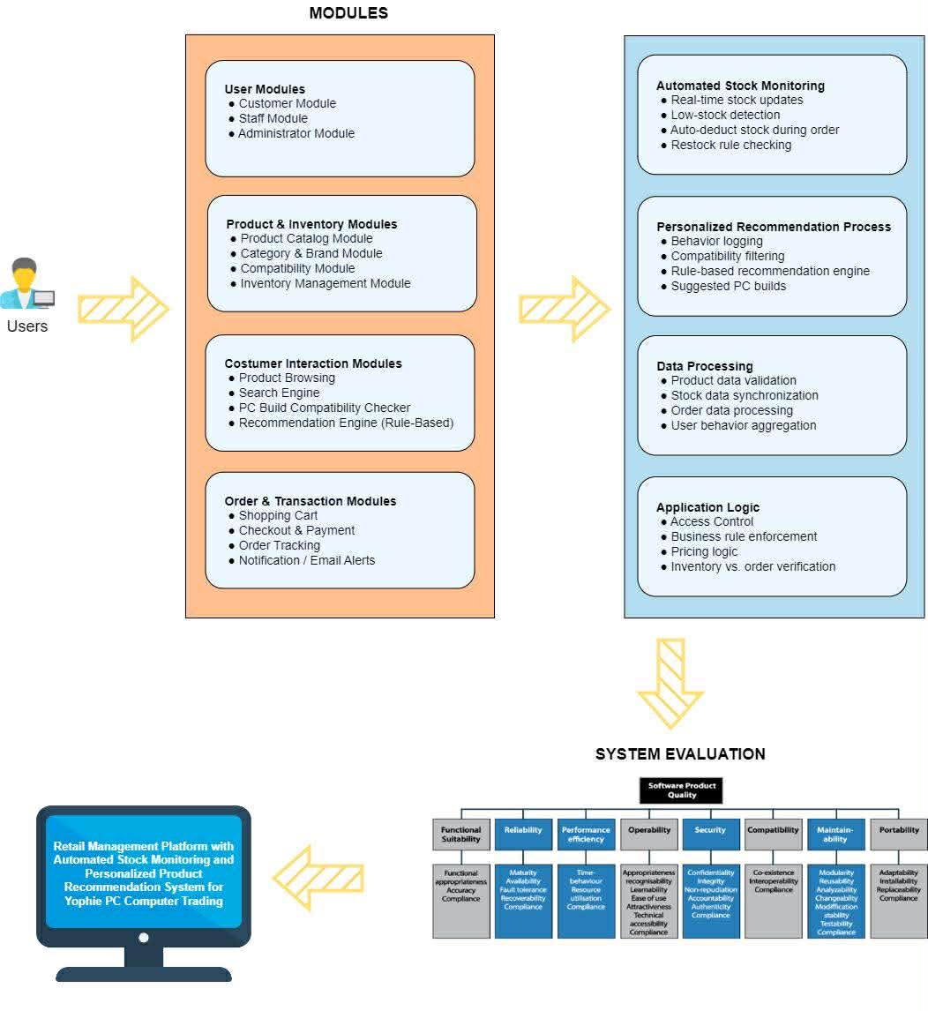

Figure 1. Conceptual Framework

CHAPTER 2

THEORETICAL FRAMEWORK OF THE PROJECT
Review of Related Literature, Studies, and Systems
This chapter provided a comprehensive review of related literature and studies, both local and international, sourced from credible materials such as published research, thesis manuscripts, scholarly articles, and authoritative online resources. The review served as a foundational guide for the researchers in conducting the study and established a framework for understanding its relevance. Furthermore, it examined and synthesized prior research to highlight connections, support the study’s rationale, and deepen the understanding of its significance.
Online Retail Platforms
The digital transformation of online retail platforms underscores the growing importance of information sharing, platform structure, and consumer behavior in shaping the performance of modern retail ecosystems. Zhang et al. (2023) highlight how virtual showroom deployment enhances customer engagement by offering immersive product visualization that reduces purchase uncertainty. Their findings shows that allowing consumers to interact with digital product displays increases trust, boosts confidence, and positively influences purchase decisions an essential factor for retail businesses offering complex or high-involvement products such as computer hardware.
Aligned with this, studies by Zhong et al. (2023) and Ha et al. (2022) emphasize the strategic benefits of information sharing across online retail channels. Zhong et al. (2023) demonstrate that coordinated data exchange between suppliers and retailers improves operational efficiency, minimizes decision asymmetry, and enhances overall platform performance. Ha et al. (2022) further examine how supplier encroachment and channel structure are shaped by the transparency of shared information, revealing that strong information flow helps retailers maintain competitiveness within multi-channel environments. These insights highlight the importance of accurate, real-time data reinforcing the need for a system capable of automated stock monitoring.
Hagen et al. (2023) contribute to the consumer behavior aspect by identifying both place-specific and non-place-specific motivations that drive users toward local online retail platforms. Their research shows that consumers value platforms that offer convenience, personalization, and a sense of local trust, particularly when these platforms provide context-aware recommendations that meet individual needs. Collectively, these studies demonstrate how virtual interaction technologies, efficient information sharing, strategic channel management, and personalized consumer engagement support the development of a Retail Management Platform with Intelligent Stock Monitoring and Personalized Product Recommendation features suited for businesses such as Yophie PC Computer Trading.
Automated Inventory Systems
Recent research on inventory management emphasizes the growing need for automation to address the operational challenges experienced by small and medium-sized enterprises (SMEs). Ugbebor, Adeteye, and Ugbebor (2024) highlight how integrating Internet of Things (IoT) technologies into inventory systems enhances accuracy, visibility, and responsiveness across the supply chain. Their study demonstrates that real-time data collection, automated tracking, and sensor-enabled monitoring significantly reduce carrying costs and human intervention, allowing businesses to maintain optimal stock levels with greater efficiency. These findings underscore how automated and IoT-driven systems can help SMEs overcome common inventory challenges such as overstocking, stockouts, and inaccurate manual records.
Supporting this argument, Madamidola et al. (2024) provide a comprehensive review of existing inventory management systems, emphasizing the limitations of traditional manual processes. Their analysis reveals that conventional inventory methods often suffer from human error, delayed updates, and inconsistencies in documentation—issues that can directly affect business performance and profitability. By contrast, modern automated systems centralize data, provide real-time updates, and streamline record-keeping, making inventory processes more reliable and scalable. They also highlight how digital platforms offer improved organization, faster retrieval of information, and better control over stock movements compared to manual approaches.
Taken together, the findings of these studies emphasize the critical role of automation and digital technologies in transforming inventory management practices. Both Ugbebor et al. (2024) and Madamidola et al. (2024) point to the need for SMEs to adopt smarter, technology-enabled systems to enhance operational efficiency, minimize losses, and improve decision-making. Their work collectively supports the relevance of developing a Retail Management Platform with Intelligent Stock Monitoring, as such systems offer the
accuracy, real-time insights, and reliability necessary for modern business environments.
Recommender Systems in E-Commerce
Recent developments in e-commerce recommender systems emphasize the increasing importance of personalization and intelligent filtering techniques in enhancing user experience. Hussien, Rahma, and Abdul Wahab (2021) provide an overview of recommendation systems for e-commerce, highlighting how algorithms such as collaborative filtering, content-based filtering, and hybrid models support more accurate and meaningful suggestions for online shoppers. Their study underscores that well-designed recommender systems help customers navigate large product catalogs more efficiently, reduce decision fatigue, and increase purchasing confidence. Complementing this, Salunke and Nichite (2022) discuss the challenges associated with big data–driven recommender systems, such as scalability issues, cold start problems, data sparsity, and maintaining up-to-date user profiles. They also present potential solutions, including improved data preprocessing, hybrid recommendation techniques, and the use of contextual information, all of which aim to strengthen system performance and user satisfaction.
Further expanding on these concepts, Bektemyssova, Guldana, and Yerassyl (2024) examine the application of recommender systems within e-commerce platforms, emphasizing their role in product discovery, sales optimization, and customer retention. Their findings highlight that integrating recommender systems into online retail interfaces not only improves the relevance of suggested products but also increases overall platform engagement and revenue generation. Collectively, the reviewed studies demonstrate the critical role of recommendation technologies in modern e-commerce, showing how intelligent algorithms, data-driven insights, and system optimization techniques contribute to more personalized, efficient, and user-centered online shopping experiences. These insights further support the importance of incorporating a personalized product recommendation module within a Retail Management Platform for Yophie PC Computer Trading.
Rule-based Matching Systems
As conversational technologies advance quickly, rule-based chatbot systems have been crucial in automating user interactions on different digital platforms. These systems depend on established rules, keyword identification, and organized conversation patterns to provide reliable and expected replies. As companies keep seeking effective communication tools for customer support, data retrieval, and process automation, scholars have explored the advantages and constraints of rule-based chatbots in practical uses. Thorat and Jadhav (2020) emphasize that these systems enhance operational efficiency by facilitating automated replies to frequent user inquiries, minimizing manual effort, and increasing response speed.
Nonetheless, in spite of their benefits, rule-based chatbots encounter various implementation obstacles that impact their overall efficiency and user contentment. Thorat and Jadhav (2020) highlight significant problems like restricted contextual comprehension, challenges in managing vague or partial user inputs, and the lack of flexibility to move outside established patterns. Such limitations frequently lead to repetitive or incorrect answers when discussions stray from anticipated situations. The authors also highlight technical difficulties such as maintenance intricacies, scalability issues, and the necessity for ongoing rule modifications to meet changing user requirements.
These constraints highlight the need for creating systems that feature adaptable frameworks and well-structured rule sets to guarantee dependability. The research shows that although rule-based chatbot systems provide simplicity, affordability, and straightforward implementation, their inflexibility limits their capacity to facilitate dynamic and natural conversations. Thorat and Jadhav (2020) emphasize the necessity for hybrid or advanced conversational models that merge structured rule-based systems with machine learning or natural language processing methods. These advancements would enable developers to address the limitations of conventional rule-based systems and create more adaptable, user-focused conversational agents that can manage intricate inquiries fostering the larger trend toward more intelligent automated.
Retail Management Digital Tools
The Digital transformation tools are crucial in defining contemporary retail practices, impacting both internal business functions and customer engagements. Halstian (2025) highlights that digital technologies such as sales analytics software, automated tracking systems, and customer management platforms significantly enhance the accuracy and efficiency of sales operations. These tools allow retailers to monitor sales performance in real time, reduce errors associated with manual processes, and support more informed decision-making. Complementing this insight, Wong, Loh, and Hardoon (2022) emphasize that digital retail investments including mobile financial tools, retail investment platforms, and digital advisory systems not only streamline retail operations but also contribute to improving the financial well-being of Filipino consumers. Their findings suggest that the adoption of digital retail systems strengthens both business productivity and consumer empowerment.
Together, these studies affirm that integrating digital technologies improves operational workflows and enables retailers to respond more effectively to evolving market demands.
Furthermore, digital transformation also shapes consumer behavior and influences the broader retail experience. Sagar (2024) notes that advancements in digital technologies have redefined customer expectations, with modern consumers seeking fast, seamless, and personalized interactions when engaging with retail platforms. Features such as online catalogs, search automation, and AI-driven product recommendations enhance convenience and satisfaction by providing tailored shopping experiences. Adding to this perspective, Novino, Caminong, and Andres (2024) found that Filipino consumers increasingly use online retail platforms as a form of “retail therapy,” driven by a cultural mindset encapsulated in the phrase “Deserve Ko ‘To.” Their research reveals that emotional gratification, ease of access, and digital convenience motivate consumers to shop online, highlighting how digital environments influence psychological and behavioral decision patterns. Taken together, these studies underscore the essential role of digital tools not only in optimizing retail management but also in shaping consumer motivations, preferences, and interactions further reinforcing the importance of building an automated and technology driven retail management system.

Stock Monitoring and Dashboard Analytics
The increasing use of business intelligence tools has significantly transformed how organizations manage financial reporting and decision-making processes. Mahmud and Ikbal (2024) emphasize that modern platforms such as Power BI enable real-time dashboarding, allowing businesses to visualize financial data instantly and monitor performance indicators with greater accuracy. Their review highlights how predictive analytics tools help identify trends, forecast financial outcomes, and support more informed strategic planning. This is consistent with Ligot et al. (2022), who found that the growing demand for data analytics skills in the Philippines is driven by organizations’ increasing reliance on data-informed decision-making. Their labor market intelligence report reveals that industries are rapidly adopting analytics-driven tools to enhance operational transparency, accountability, and reporting efficiency. By integrating advanced data analytics into financial reporting, organizations are able to minimize errors, improve transparency, and enhance the timeliness of financial insights key components for maintaining operational efficiency in a rapidly evolving business environment.
Building on these developments, Anirudh (2023) discusses the evolution of financial decision support systems, noting a shift from traditional dashboards to more sophisticated predictive analytics frameworks. These systems utilize historical and real-time data to guide decision-makers in evaluating risks, optimizing resources, and anticipating future business conditions. The findings of Filani, Nwokocha, and Alao (2022) further reinforce this trend, demonstrating how vendor performance analytics dashboards integrate procurement, quality, and cost metrics to support real-time decision-making. Their work shows that automated analytics dashboards provide managers with immediate access to comprehensive operational indicators, improving organizational responsiveness and resource allocation. According to Anirudh (2023), the integration of predictive technologies enables organizations to move beyond simple data visualization toward proactive, data-driven decision-making. Together, these studies demonstrate how business intelligence tools and predictive analytics play a vital role in strengthening financial and operational management practices, underscoring the importance of technology-driven solutions in supporting accurate reporting and strategic planning.
Small Business Retail systems
Effective retail management relies heavily on accurate and efficient transaction processing systems. Ramadhani, Nindyasari, and Murti (2025) emphasize that a web-based Point of Sale (POS) system can significantly enhance operational performance for small-scale retail businesses by streamlining sales transactions, improving data accuracy, and providing real-time access to inventory and financial records. Their study shows that web-based systems reduce dependency on manual processes, which are prone to human error, and enable retailers to centralize their operations through an accessible online platform. This modern approach allows small businesses to maintain better control over their sales data and improves the overall reliability of retail operations.
In addition to improving transaction management, a well-designed POS system also supports inventory tracking and decision-making processes. Ramadhani et al. (2025) explain that integrating inventory functions within a web-based POS allows retailers to monitor stock levels automatically, identify fast-moving or low-stock items, and generate accurate sales reports with ease. This functionality is essential for preventing stock shortages and ensuring timely restocking, which ultimately enhances customer satisfaction and business efficiency. Regular monitoring and automated stock updates help eliminate operational gaps and enable small-scale retailers to maintain consistent service quality, reinforcing the need for technology-driven retail management solutions.
Inventory Management Applications
The IoT-based inventory management systems are increasingly being adopted to address challenges related to food waste, perishability, and efficient resource utilization. Ortiz, Bautista, Dimailig, and Llamzon (2023) developed a recipe recommendation system that integrates IoT technology with household food inventory monitoring to reduce waste and optimize food consumption. Their study highlights how real-time tracking of perishable items allows users to make informed decisions about which ingredients to use before they expire. According to Ortiz et al. (2023), the system leverages sensor-generated data to recommend recipes tailored to the available ingredients, ensuring that food is consumed efficiently while minimizing spoilage. This approach demonstrates how IoT-driven inventory systems can support sustainability and improve household management practices.
Beyond reducing waste, IoT-based food inventory systems contribute to improved decision-making and user convenience. By providing accurate, automated updates on food availability and expiration timelines, these technologies help households plan meals more effectively and reduce unnecessary purchases. Ortiz et al. (2023) explain that integrating IoT with recommendation features increases user engagement by offering practical, personalized suggestions that align with current inventory levels. The study underscores the potential of IoT-enabled solutions not only to streamline inventory monitoring but also to promote responsible consumption, making them valuable tools in advancing household efficiency and sustainability.
Web-based Business Platforms
The digital tools designed for business validation have transformed how startups assess market readiness and refine their business strategies. Velasco, Rentucan, Largo, and Racaza (2024) introduced a web-based market validation tool that supports the Modified Startup Business Company Validation Methodology, enabling entrepreneurs to gather, organize, and analyze customer feedback more efficiently. Their study highlights that a digital validation platform allows startups to evaluate customer interest, test assumptions, and identify potential market risks with greater accuracy than traditional manual methods. This growing reliance on digital platforms aligns with the findings of Pasco et al. (2024), whose multivendor e-commerce system for Filipino fishermen demonstrates how web-based tools improve market accessibility, streamline vendor engagement, and facilitate efficient interaction between sellers and buyers. Similarly, Blancaflor, Nora, and Zacarias (2022) shows that a web-based customer relationship management (CRM) platform can enhance data management and client communication in event services, further proving that digital systems significantly strengthen operational workflows. By centralizing data collection and providing structured evaluation metrics, these tools collectively enhance decision-making and help startups validate their business concepts before large-scale investment.
Traditional validation approaches, while accessible, often lack the systematic process and analytical depth required to effectively assess product-market fit. Velasco et al. (2024) explain that reliance on manual surveys and unstructured feedback can lead to inconsistent data, limited reach, and delays in evaluating business feasibility. Studies such as Pasco et al. (2024) reinforce this limitation by demonstrating that digital platforms enable wider market participation and real-time engagement, which manual processes cannot achieve. Additionally, Blancaflor et al. (2022) emphasize that web-based systems introduce automation, organized customer profiling, and streamlined communication, resulting in more coherent and actionable insights. In contrast to traditional methods, the proposed web-based validation tool automates these processes, facilitating faster data analysis and more reliable insights. This shift toward digital validation methods demonstrates how web-based solutions improve the accuracy, efficiency, and scalability of startup evaluation processes, ultimately supporting more informed entrepreneurial decisions.
Recommendation Systems for Filipino SME’s
Understanding how digital experiences shape customer behavior is essential for developing effective online business platforms, particularly for SMEs. Pleno and Reclusado (2024) emphasize that user experience, satisfaction, and trust significantly influence customer loyalty, demonstrating the need for intuitive interfaces and reliable online services. Similarly, Samonte et al. (2025) highlight how digital applications, such as their looking for platform, improve accessibility to local services through user-centered design and trustworthy digital interactions. Their findings illustrate that well-crafted digital solutions enhance convenience, strengthen user engagement, and support the sustainability of online platforms, especially those serving local communities and small businesses.
Complementing these insights, Escolano et al. (2025) show that SMEs are increasingly driven to adopt big data analytics due to its perceived benefits in predicting market trends, improving competitiveness, and supporting strategic decisions. Their study reveals that technological readiness and organizational
capability significantly influence adoption intentions, underscoring the need for businesses to integrate data-driven tools into their operations. Together, these studies demonstrate that customer experience, digital innovation, and analytics adoption form a unified foundation for modern business systems supporting the relevance of developing a retail management platform that leverages automated stock monitoring and personalized product recommendations to enhance efficiency and customer satisfaction.
POS or Retail Software
The Retail environments play a critical role in shaping consumer behavior, as demonstrated by Crespi et al. (2025), who examined how retailer density and point-of-sale marketing influence purchasing patterns among youth in the Philippines and Vietnam. Their findings show that strategic product placement, visibility, and in-store promotional materials significantly affect consumer decisions. Although their study centers on tobacco-related products, the broader implication is clear: point-of-sale design and marketing strategies carry substantial persuasive power in any retail setting. This highlights the importance of optimizing store layout, product arrangement, and marketing displays to enhance customer engagement and guide purchasing behavior effectively.
Recent studies indicate that digital abilities and the adoption of technology are gaining equal significance to traditional in-store tactics in retail. Guillen (2023) identifies that shoppers currently anticipate seamless transitions between online and in-store shopping experiences, while Jacob (2024) demonstrates that cashless transactions enhance convenience and increase customer satisfaction. In contemporary retail management, it’s essential to combine robust digital tools like automated inventory monitoring and tailored recommendation systems with traditional physical retail methods.
Synthesis and Relevance of the Study
The literature shows that digital transformation and data-driven tools are reshaping retail by improving customer experience, loyalty, and operational efficiency. Technologies such as cashless payments, web-based POS systems, automated inventory tools, and recommender systems enhance convenience, accuracy, and product visibility especially in specialized sectors like computer hardware retail. While existing platforms like e-commerce and CRM systems offer useful features, they lack integrated solutions that combine real-time stock monitoring with personalized product recommendations. This gap supports the need for a customized Retail Management Platform for Yophie PC Computer Trading, designed to provide intelligent suggestions, accurate inventory tracking, and an improved digital customer experience.
Literature Matrix
Table 1. Literature Matrix
Author(s) & Year | Title | Purpose | Methodology | Key Findings | Relevance to Capstone
Velasco, Rentucan, Largo, & Racaza (2024)  Wong, Loh, & Hardoon (2022)  Pasco, Vicedor, Recena, Rodriguez, Tomagos, & Serrano (2024)  Mahmud & Ikbal (2024) | A web-based market validation tool for the modified startup business company validation methodology  Evaluating digital retail investment as a tool to improve financial well-being in the Philippines  SeaSavor: A multivendor e-commerce website for the fishermen in the Philippines  Power BI and data analytics in financial reporting | To create a digital tool that assists startups in validating business ideas and assessing customer interest.  To examine how digital retail platforms influence consumer financial behavior and outcomes.  To develop an online multivendor platform enabling fishermen to sell products digitally.  To review real-time dashboarding and predictive analytics for improving financial reporting. | System development; user testing; process modeling via validation framework.  Data analytics; financial behavior modeling; platform evaluation.  System development; prototyping; functional testing  Literature review; BI tool analysis; predictive analytics assessment | The tool improved the accuracy and speed of gathering customer feedback and evaluating business feasibility.  Digital retail tools help users track investments, improve financial decisions, and access inclusive digital services.  The e-commerce system improved market access, buyer–seller communication, and digital transactions in local communities.  BI dashboards enhance transparency, accuracy, and timeliness in financial decision-making. | Supports the capstone’s goal of building a digital retail management system with structured validation and analytics capabilities.  Shows how digital retail platforms enhance decision-making, supporting automated financial analytics in your system.  Demonstrates the potential of web-based retail platforms aligned with your capstone’s aim to automate digital retail processes.  Supports the integration of analytics and dashboards into your capstone for better reporting and automated insights.

CHAPTER 3

METHODOLOGY
This study employed a quantitative research approach and utilized the Agile development methodology to design and develop a retail management platform tailored for Yophie PC Computer Trading in Calamba City, Laguna. The Agile method supported iterative, sprint-based development, which enabled continuous refinement of key system components, including automated stock monitoring, product management, and the personalized recommendation module.
The system was developed as a web-based platform that enabled administrators to track inventory levels, record transactions, and manage product listings in real time. The stock monitoring feature was tested using quantitative metrics such as update accuracy, system response time, and inventory data consistency. In addition, the recommendation system was evaluated based on its ability to generate relevant product suggestions aligned with customer needs and preferences. Notification features were also integrated to alert administrators of low-stock items and critical inventory changes, thereby supporting timely decision-making and improving overall retail operational efficiency.
Project Design
The proposed Retail Management Platform with Intelligent Stock Monitoring and Personalized Product Recommendation System for Yophie PC Computer Trading was designed using a modular, web-based architecture that integrated a Vue 3 frontend, a Laravel 10 backend, and a centralized MySQL database. As illustrated in Figure 2, the system was organized into three primary components: the User Interaction Layer, the Frontend Application Layer, and the Backend Processing and Data Management Layer.
The User Interaction Layer consists of the two main user groups administrators/staff and customers who interact with the system through various inputs and receive corresponding outputs. Administrators encode product details, update stocks, manage transactions, and oversee system operations, while customers browse product catalogs, view detailed specifications, and receive personalized recommendations. All user actions are routed to the frontend interface for further processing.
The Frontend Application Layer, developed using Vue 3, provides a responsive and intuitive user interface accessible across desktops and mobile devices. This layer serves as the visual environment where users view real-time inventory levels, explore product listings, and receive recommendation outputs. It facilitates communication with the backend through structured API requests and displays backend responses dynamically, ensuring smooth system navigation and interaction.
The Backend Processing and Data Management Layer, built with Laravel 10, contains the core functional modules of the platform. These include User Authentication, Dashboard, Inventory Management, Product Catalog and Details, Product Recommendation, Transaction and Records, and Notification and Alerts. The backend is responsible for processing incoming requests, executing business logic, generating recommendations, updating inventory, and handling all transactional operations. All processed information is stored in a centralized MySQL database, which maintains product data, inventory records, and transaction logs securely.
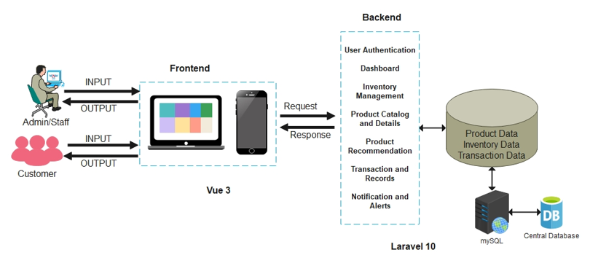
By integrating user interaction, a modern frontend framework, a robust backend, and a unified database, the architecture enables an efficient, automated, and data-driven retail workflow. It ensures accurate stock monitoring, enhances product management, delivers personalized recommendations, and improves overall operational performance for Yophie PC Computer Trading.

Figure 2. System Architecture
Evolutionary Prototyping Model
This diagram represents the software development methodology used in the project Evolutionary Prototyping. It highlights iterative development cycles involving requirement gathering, prototype creation, user evaluation, and refinement. This approach ensures that the Retail Management Platform evolves based on continuous feedback from Yophie PC Computer Trading, resulting in a more accurate, user-friendly, and business-aligned final system. The development process consists of the following stages:
Requirements Gathering. This phase focuses on identifying the essential needs of Yophie PC Computer Trading. Consultations with the business owner and staff helped determine the key system requirements, such as real-time stock tracking, automated inventory updates, product compatibility checks, and personalized recommendations for computer parts. The insights gathered from actual retail challenges such as stock discrepancies, manual recording delays, and customer difficulty choosing compatible components guided the direction of the entire system development.
Build Prototype. Based on the identified requirements, an initial prototype of the retail platform was developed. This early version included the basic structure of the Vue 3 frontend, simple product listings, manual inventory updating, and a minimal Laravel backend. The goal of this stage was to validate fundamental workflows, including product viewing, admin login, and basic stock management, before implementing automation and recommendation features.
Customer Evaluation. The prototype was presented to Yophie PC staff for initial evaluation. Users interacted with the system to assess usability, navigation flow, and flexibility. Feedback was collected regarding interface design, ease of updating product details, clarity of stock information, and overall user experience. This step made it possible to identify improvements early in the development process.
Refinement. Based on feedback from users, revisions were made to enhance the prototype. Enhancements included improving product categorization, optimizing inventory input fields, reorganizing user interface components, and adjusting form validations. This refinement stage ensured that the platform became more suited to real-world operations and user preferences.
Design. Once the refined concept was validated, a more detailed system design was created. This included defining the architecture of automated stock monitoring, mapping the data flow between frontend and backend, designing the product management system, and planning the personalized recommendation module. UI/UX layout, database schema, and API structures were finalized to ensure smooth integration of all system components.
Implement. With a complete design, full-scale implementation began. Automated stock monitoring logic, Laravel API endpoints, MySQL database functions, product management features, and recommendation algorithms were developed. The Vue 3 interface was enhanced to support real-time data updates and responsive display for both admin and customers. Product compatibility checks and rule-based recommendations were integrated as core features of the system.
Test. After deployment, the system enters the maintenance phase. Regular updates are performed to improve system performance, fix bugs, enhance recommendation rules, and update product categories or component compatibility logic. Maintenance ensures the platform remains reliable, scalable, and aligned with the evolving business needs of Yophie PC Computer Trading.
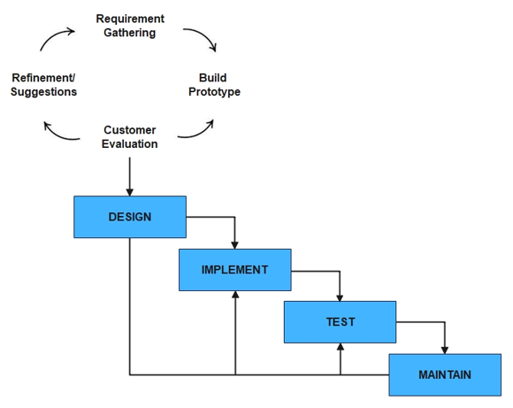
Maintain. After deployment, the system enters the maintenance phase. Regular updates are performed to improve system performance, fix bugs, enhance recommendation rules, and update product categories or component compatibility logic. Maintenance ensures the platform remains reliable, scalable, and aligned with the evolving business needs of Yophie PC Computer Trading.

Figure 3. Evolutionary Prototyping Model of Retail Management Platform

Project Locale
The implementation of the capstone project titled “Retail Management Platform with Intelligent Stock Monitoring and Personalized Product Recommendation System for Yophie PC Computer Trading” took place at Yophie PC Computer Trading, located in Calamba City, Laguna. This business site was selected because it directly represented the intended users of the system and provided an appropriate environment for analyzing real retail operations, inventory challenges, and customer interaction patterns. During the initial consultation, the researchers met with the store owner and staff to present the project proposal, discuss its objectives, and identify the specific operational issues that the system aimed to address.

Yophie PC Computer Trading primarily offered computer components, peripherals, and accessories, making it an ideal setting for developing and testing features such as automated stock monitoring, product management, and personalized recommendation functionalities. Its existing workflow—manual stock updates, customer-driven inquiries, and compatibility checking—provided real-world scenarios that allowed the system to demonstrate its effectiveness. Implementing the platform in this location enabled the researchers to gather accurate data, observe system usability, and validate its performance in an actual retail environment.

Figure 4. Owner of the Yophie PC Computer Trading
Model Development
The figure presented the structured workflow used in developing the personalized product recommendation model for the Retail Management Platform designed for Yophie PC Computer Trading. This model served as a key component in improving the customer shopping experience by analyzing product attributes, customer needs, and compatibility between computer components. The development process consisted of several sequential stages that ensured product data was correctly gathered, processed, and translated into meaningful recommendations. These steps helped generate accurate, relevant, and user-specific suggestions that supported informed purchasing decisions. The stages were explained as follows:
Data Collection and Preparation. The first stage involved gathering product-related data from the store’s existing inventory, such as component specifications, categories, compatibility details, and customer browsing behavior. The collected data was cleaned, organized, and encoded into structured formats to ensure consistency. This process included mapping product attributes (e.g., processor socket type, motherboard chipset, RAM generation), normalizing text fields, and ensuring that compatibility rules were properly defined. Preparing high-quality data was essential for producing reliable recommendation outputs.
Feature Extraction and Rule Definition. Once the data was prepared, the system identified key attributes that influenced product recommendations. These included compatibility rules (such as matching CPU socket types with supported motherboards), performance categories, and customer preference indicators. Rule-based logic was formulated to ensure that the system recommended only items that met technical compatibility standards and aligned with customer-selected criteria. This stage established the foundation for a meaningful and accurate recommendation engine.
Model Construction. Using the selected parameters, the recommendation model is developed and trained using historical product data, customer interactions, and inventory records. During this phase, the model learns patterns in customer preferences, purchasing behavior, and product compatibility relationships. Proper model construction ensures that the system accurately represents product associations and user interests, enabling reliable and relevant recommendation outputs that support informed purchasing decisions.
Parameter Experimentation and Refinement. After constructing the model, fine-tuning is performed to improve recommendation relevance and reduce mismatches. Adjustments may include enhancing compatibility filters, refine product ranking criteria, or adjust weight values for attributes such as brand, performance level, or price. User feedback and test scenarios are used to refine the system, ensuring that recommended products are practical, accurate, and aligned with customer expectations.
Recommendation Generation. Once refined, the system generates personalized recommendations based on customer actions such as viewing a product, selecting a category, or adding an item to the cart. The model produces a ranked list of compatible or complementary items (e.g., suggesting compatible motherboards for a selected CPU, or appropriate RAM modules for a chosen motherboard). These results serve as the foundation for the personalized product recommendation feature.
Output Integration. The final stage involves integrating the recommendation model into the platform’s interface. Suggested products are displayed on the Vue 3 front end, where customers can easily view compatible items and alternative options. Recommendations dynamically update in real time based on inventory status, ensuring that only available products are shown. This improves decision-making, enhances shopping convenience, and supports a more efficient retail experience.
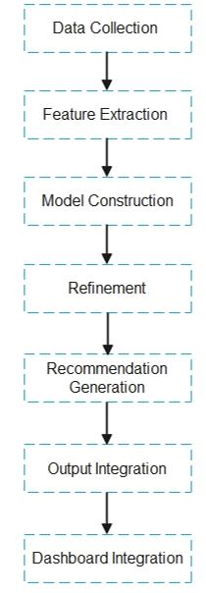
Dashboard Integration. The final stage involves presenting real-time stock updates, product details, and personalized recommendations on the system’s dashboard. This visual interface allows administrators and staff to easily monitor inventory levels, track transactions, and view important alerts, while customers can access updated product information and relevant suggestions. The dashboard enhances decision-making by providing clear, organized, and timely data that supports efficient retail operations and improves the overall user experience.

Figure 5. Retail Management Platform Model
Software Development

This section describes the software tools utilized in the development of the Retail Management Platform with Intelligent Stock Monitoring and Personalized Product Recommendation System. Each tool was selected based on its reliability, performance, and suitability for building a scalable, modern web application. These software technologies ensured efficient development, seamless system integration, and a stable environment for deployment.
Frontend Technologies
Vue 3 + TypeScript. Vue 3 is a progressive JavaScript framework designed for building interactive user interfaces. Paired with TypeScript, it enables strongly typed components, improved debugging, and enhanced maintainability. Vue 3’s reactivity system, component-based architecture, and virtual DOM make it suitable for creating dynamic dashboards, inventory screens, and customer recommendation views within the retail platform.
Vite. Vite is a modern build tool and development server known for its lightning-fast performance. It uses native ES modules during development, drastically reducing build time compared to traditional bundlers. Vite was used to streamline the frontend development workflow, ensuring minimal delays when compiling and testing UI components.
Bootstrap 5 / Metronic UI. Bootstrap 5 provides a responsive, mobile-first design foundation using prebuilt CSS and JavaScript components. Metronic UI builds upon Bootstrap by offering professional layouts, dashboards, and interface elements. These tools ensured a polished, consistent, and user-friendly interface for both employees and customers interacting with the system.
SCSS. SCSS (Sassy CSS) is an extension of CSS that adds variables, nesting, and mixins, enabling cleaner and more maintainable styles. It was used to customize Bootstrap components and create a consistent visual theme across all pages of the system.
Axios. Axios is a lightweight HTTP client used to communicate with the backend API. It simplifies sending requests, handling JSON responses, and managing authentication tokens, making it an essential tool for connecting frontend components to Laravel endpoints.
Lodash & Vee-Validate. Lodash is a JavaScript utility library that simplifies tasks such as data manipulation, array filtering, and object handling. Vee-Validate is a form validation framework for Vue that ensures input accuracy and prevents invalid data from being submitted. Together, these tools support the creation of reliable and error-free form components throughout the system.
Backend Technologies
Laravel 10 (PHP 8.x). Laravel is a robust PHP framework known for its expressive syntax and powerful features such as routing, middleware, and Blade templating. In this project, Laravel 10 served as the main backend structure for handling business logic, authentication, API endpoints, and system workflows. Its modular design allowed efficient implementation of features like inventory management and product recommendation generation.

Eloquent ORM. Eloquent simplifies database interactions through an object-relational mapping approach. Instead of writing raw SQL queries, developers can interact with tables using models and relationships. This enhanced development speed and ensured more secure and organized data handling.
Laravel API Resources & Validation. API Resources provide structured and uniform JSON responses, while Laravel’s validation system enforces data integrity by ensuring that only valid and sanitized information is processed. These tools were critical for maintaining a consistent communication flow between the frontend and backend.
Laravel Storage. Laravel Storage was used to securely handle image uploads, such as product photos and documentation files. It provides file organization, disk configuration, and seamless integration with the storage directory.
Database Technology

MySQL 8. MySQL 8 is a high-performance relational database management system used to store system records such as inventory data, sales transactions, user accounts, and product information. It supports ACID-compliant transactions, robust indexing, and advanced SQL features that ensure data accuracy and consistency. Its scalability and security enable the retail management platform to handle real-time stock updates, multiple users, and expanding datasets efficiently, making it a reliable backend solution for modern retail operations and system integration needs.
Infrastructure and Deployment
Docker & Docker Compose. Docker provides containerized environments that ensure consistent development and deployment across different machines. Docker Compose allows multiple services such as the frontend, backend, and database to run simultaneously. This setup simplified configuring, testing, and deploying the entire system.
Nginx. Nginx is a high-performance web server used to serve the frontend application and act as a reverse proxy for the backend API. Known for its stability and low memory usage, Nginx ensured fast routing and efficient server responses, especially under high user load.
Visual Studio Code. Is a powerful, lightweight source code editor that supports multiple programming languages and offers tools for debugging, version control, and extensions. It is widely used by developers working on both hardware programming and web development in IoT projects, providing an efficient environment for building integrated poultry monitoring systems.
The hardware specifications for the laptop or computer used in this project are detailed in the table. These include a minimum of 16GB of RAM to ensure sufficient memory for smooth operation. The storage is provided by a Samsung SSD 970 EVO Plus with 500GB, offering fast read and write speeds to accommodate project files and software. The system is powered by an Intel Core i5 processor, which is capable of handling the project's processing requirements efficiently. For graphics, the laptop is equipped with an NVIDIA GeForce 4GB GTX1650, ensuring high-performance visual processing. The system operates at a clock speed of 3.60GHz, which ensures quick processing speeds and optimal performance for complex tasks. These specifications ensure that the computer can handle the demands of the project effectively.
Table 2. Hardware Requirements Used for Laptop/Computer
Requirements Used
RAM  HDD/SSD  CPU  GPU | 16GB  500GB Samsung SSD 970 Evo Plus Core i5 3.60GHz  4GB GTX 1650

Project Development
The system titled “Retail Management Platform with Intelligent Stock Monitoring and Personalized Product Recommendation System for Yophie PC Computer Trading” was developed using the Agile Scrum methodology. This flexible and iterative approach supported continuous feedback, collaboration, and progressive refinement, making it highly suitable for a system that involved dynamic retail processes, evolving requirements, and multiple functional modules.
The project was organized into one-to-two-week sprints, with regular stand-up meetings conducted to monitor progress, identify challenges, and implement timely adjustments throughout development. Core features such as automated stock monitoring, product catalog management, transaction processing, user authentication, and the personalized product recommendation module were developed and integrated incrementally. This iterative approach allowed continuous testing, refinement, and improvement of each system component. Through this adaptive development process, the system evolved based on user feedback and operational requirements from Yophie PC Computer Trading. As a result, the final platform became more efficient, accurate, reliable, and well-aligned with the actual day-to-day business processes and retail management needs.
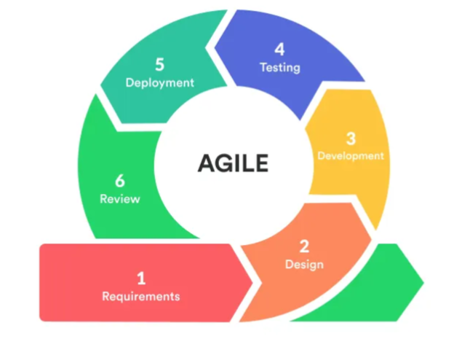

Figure 6. Agile Scrum Methodology
Scope
This research focused on developing a Retail Management Platform with Intelligent Stock Monitoring and Personalized Product Recommendation System for Yophie PC Computer Trading in Calamba City, Laguna. The system provided real-time inventory tracking to ensure accurate stock levels and reduce manual errors, while its recommendation feature analyzed product data and customer preferences to suggest compatible computer components. Store administrators and ICT personnel managed the platform and maintained data accuracy. Overall, the project aimed to streamline store operations, enhance customer decision-making, and improve business efficiency through automation and intelligent recommendations.

Design
The system followed a modular, user-centered design to ensure streamlined functionality and ease of use within retail operations. It integrated several key modules that worked together to automate inventory processes, enhance product management, and support intelligent decision-making. The Login Module provided secure authentication for administrators and staff, ensuring that only authorized users could access sensitive operational data.
The Settings Module allowed administrators to update account details and configure system preferences to match the store’s workflow. Central to the platform was the Dashboard Module, which consolidated and displayed real-time analytics such as current stock levels, sales updates, and recommended products based on customer interactions.
The Inventory Management Module was responsible for tracking product quantities, preventing stock discrepancies, and automatically updating item availability after each transaction. The Product Management Module handled the creation, updating, and organization of product listings, specifications, and categories. Meanwhile, the Product Recommendation Module analyzed item attributes, compatibility rules, and customer browsing behavior to generate personalized and relevant suggestions. The Notification Module issued automated alerts for low-stock items, out-of-stock situations, and important system updates, enabling timely administrative actions.
This modular architecture ensured clarity, usability, and efficient system maintenance while supporting accurate inventory tracking, improved product visibility, and an enhanced shopping experience for customers of Yophie PC Computer Trading.
Product Backlogs
The product backlog for the Retail Management Platform outlined the essential features required to support the daily operations of Yophie PC Computer Trading. As shown in the figure, the system prioritized modules that enabled administrators and staff to securely access the platform, manage product listings, monitor inventory in real time, and oversee the overall retail workflow. Key tasks such as updating stock quantities, recording transactions, tracking inventory adjustments, and monitoring system health formed the core responsibilities of internal users. Meanwhile, customers benefited from features that allowed them to explore available products and receive compatibility-based recommendations that simplified decision-making during PC component selection.
The backlog also included system-driven functionalities such as customer activity tracking to enhance recommendation accuracy, notification alerts for low-stock events and system updates, and visual analytics for examining sales trends and inventory performance. Each item was strategically prioritized to improve productivity, minimize manual errors, and ensure that both staff and customers had access to accurate and up-to-date information. Collectively, these modules formed a cohesive, user-centered system architecture that enhanced operational efficiency, supported informed retail decisions, and delivered an optimized shopping experience tailored to the needs of Yophie PC Computer Trading.
Table 3: Product Backlog for Admin
Story User | Description | User / Role | Priority | Estimated Effort
Login Module  Settings Module  Dashboard Module  Inventory Management  Product Catalog Management  Recommendation Module  Notification Module  Transaction Records  Customer Activity Tracking  Graph & Chart Visualization  System Health Cheeker  Manual Log Adjustments  System Logging | As an admin, I want secure sign-in/sign-out with lockout protection (3 attempts, cooldown) so unauthorized access is prevented.  As an admin, I want to update my profile, modify system preferences, and configure store settings.  As an admin, I want to see real-time inventory summaries and product insights so I can oversee store performance quickly.  As a staff user, I want to add, update, and track product stock levels to maintain accurate inventory records.  As an admin, I want to manage product listings with details, images, categories, and compatibility attributes.  As a customer, I want to receive compatible product suggestions (e.g., CPU, motherboard) based on my selected items.  As an admin, I want alerts for low-stock, out-of-stock items, and important system updates.  As staff, I want to record purchases, update sales logs, and link transactions to inventory adjustments.  As a system, I want to store customer browsing patterns to improve recommendation accuracy.  As an admin, I want visual analytics on sales trends, stock movement, and category performance.  As an admin, I want to be alerted if modules fail or inconsistencies occur in inventory data.  As staff, I want to manually adjust stock entries if discrepancies occur during auditing.  As an admin, I want logs of all major actions (logins, edits, stock updates) for security and auditing. | Admin/  Staff  Admin  Admin  Staff/ Admin  Admin  Customer  Admin  Staff  System  Admin  Admin  Admin  Admin  Staff  Admin | High  Medium  High  High  High  High  High  High  Medium  Medium  Medium  Medium  Medium | 1 day  1 day  1.5 days  2 days  1 day  1 day  1 day  1 day  1 day  1 day  1 day  1 day  1 day

Table 4 provided an overview of the system’s main product backlog by outlining the key features, their purpose, user roles, priorities, and estimated development time. The backlog included core functions such as secure user authentication, a real-time dashboard for stock and sales insights, automated low-stock notifications, product data storage, analytics tools, and a compatibility-based recommendation engine. It also covered system settings and user management capabilities. Each feature was labeled with either a medium or high priority and was assigned a development estimate of one to two days to guide implementation planning.
Table 4. Main Product Backlog (General Features)
Story User | Description | User/Role | Priority | Estimated Effort Days
User Authentication | Login/logout system for both admin and staff with secure access control and session handling | Admin, Staff | High | 2 days
Dashboard Display | Real-time visualization of stock levels, sales summaries, low-stock alerts, and product insights. | Admin, Staff | High | 2 days
Notification System | Automated alerts for low-stock items, out-of-stock products, and important system updates. | Admin | High | 1.5 days
Product Data Storage | Automatically store and update product details, categories, variations, and compatibility metadata. | System | High | 2 days
Analytics Module | Historical data analysis and graph generation for chicken growth optimization | Admin | Medium | 1 day
Recommendation Engine  Settings Module | Generate compatibility-based and personalized product suggestions (e.g., CPU, Motherboard, RAM).  Allows admin to configure system preferences, notification rules, product categories, and display settings. | System  Admin | High  Medium | 2 days  1.5 days
User Management | Admin can add, remove, and manage staff accounts, including role assignment and permissions | Admin | Medium | 1 day

Sprint Planning for Admin
The sprint plan defined a four-phase development approach for the admin interface of Yophie PC’s Retail Management Platform. It gradually built core features from secure administrator access and a real-time performance dashboard to complete inventory and product management and detailed catalog settings. The phased strategy aimed to provide administrators with efficient and accurate tools for managing stock, organizing product data, and overseeing store activity.
Table 5. Sprint Planning for Admin Features
Sprint | Goal | Tasks | Estimated Hours/Day | Expected Outcome
1 | Establish secure admin access | – Implement login/logout module  – Add lockout protection (3 attempts + cooldown)  – Create user roles (Admin, Staff)  – Backend API authentication setup  – Vue authentication UI | 6–8 hrs/day for 2 days | Admin/Staff can securely log in and access system features
2 | Provide admin with a real-time overview of store status | – Create dashboard UI  – Display stock levels, low-stock alerts, product counts  – Add quick analytics (most viewed items, high-demand items)  – Connect backend APIs to dashboard | 6–8 hrs/day for 2 days | Admin can monitor real-time inventory and store insights
3 | Enable admin to manage products and stock | – Build CRUD for products  – Add fields (brand, category, specs, compatibility)  – Create stock update module (add/remove quantity)  – Validate stock transactions | 6–8 hrs/day for 2 days | Admin can add/update/delete products and manage stock accurately
4 | Manage detailed product catalog and compatibility attributes | – Implement category + brand structure  – Add compatibility fields (CPU, motherboard, RAM)  – Upload product images & specifications  – Ensure structured product metadata | 6–8 hrs/day for 2 days | Admin can maintain an organized and compatibility-ready product catalog

Sprint Planning for Main Product
The sprint plan gradually built Yophie PC’s Retail Management Platform by integrating authentication, a real-time dashboard, inventory and catalog management, and product recommendations, along with alerts and transaction tracking. This phased approach ensured the development of an efficient system for managing stock, product data, and customer recommendations.
Table 6. Sprint Planning for Main Product
Sprint | Goal | Tasks | Estimated Hours/Day | Expected Outcome
1 | Establish core system structure and authentication | – Implement login/logout with role-based access (Admin/Staff)  – Set session handling and lockout protection  – Configure backend API and Vue 3 auth pages | 6–8 hours/day for 2 days | Secure and stable access for system administrators and staff
2 | Develop dashboard for real-time store monitoring | – Build dashboard UI in Vue 3  – Display real-time stock levels, low-stock alerts, and product statistics  – Integrate backend analytics APIs | 6–8 hours/day for 2 days | Admin can view store performance and inventory insights instantly
3  4 | Implement Inventory Management Module  Implement Product Catalog & Compatibility Features | – Build product and stock CRUD  – Add stock adjustment functions  – Ensure correct validation for stock transactions  – Add product categories, brands, and detailed specifications  – Set compatibility fields (CPU, motherboard, RAM)  – Upload product images & metadata | 6–8 hours/day for 2 days  6–8 hrs/day for 2 days | Complete product catalog with compatibility-ready data  Admin can maintain an organized and compatibility-ready product catalog System notifies
5  6  7 | Set up Automated Stock Monitoring & Alerts  Develop Recommendation Engine (Rule-  Based)  Enable Transaction Recording & Analytics | – Define low-stock/out-of-stock rules  – Implement alert system (UI notifications)  – Store stock alert logs  – Extract product attributes  – Define compatibility-based rules  – Generate recommendation results for customers  – Implement transaction logging  – Store purchase and stock movement history  – Generate graphs for viewing trends | 6–8 hrs/day for 2 days  6–8 hrs/day for 2 days  6–8 hrs/day for 2 days  6–8 hrs/day for 2 days | admin of critical stock levels in real time  Customers receive accurate, relevant product recommendations  Admin gains access to data-driven insights and store analytics

Daily Scrum
As the sole developer of the Retail Management Platform with Intelligent Stock Monitoring and Personalized Product Recommendation System for Yophie PC Computer Trading, I conducted a daily 2-hour and 30-minute self-scrum session to track progress and remain aligned with the sprint goals. During these sessions, I reviewed completed tasks, planned the next development steps, and identified challenges that needed to be addressed. This personal workflow allowed me to continuously refine the sprint and product backlog as necessary, ensuring steady progress in developing key system features such as real-time stock monitoring, product catalog management, and compatibility-based recommendations. By maintaining this disciplined routine, I was able to work efficiently and stay focused on delivering a functional and user-centered retail management platform.
Sprint Execution
During sprint execution, I worked closely with the product owner represented by Yophie PC Computer Trading to clarify sprint deliverables, validate system requirements, and estimate the workload for each development cycle. This collaboration ensured that every sprint remained focused on developing core system features such as automated stock monitoring, real-time inventory updates, and personalized product recommendations based on component compatibility. By maintaining consistent communication with the stakeholders, I was able to align development priorities with actual business needs, ensuring that the platform effectively supported daily retail operations and enhanced the overall customer shopping experience.

Sprint Review
During the review, I presented the implemented system features to the product owner, including automated stock tracking, product catalog management, and the personalized recommendation module. This process helped assess whether key components such as real-time inventory monitoring, compatibility-based suggestions, and updated product listings were functioning according to the operational requirements of Yophie PC Computer Trading. The review ensured that each feature contributed to smoother retail workflows, improved accuracy in stock management, and a more guided and convenient shopping experience for customers.
Sprint Retrospective
At the end of each sprint, I conducted a retrospective to evaluate progress, identify challenges, and assess the effectiveness of the tools and workflow used in developing the Retail Management Platform. The reflection focused on how well each sprint contributed to improving inventory automation, product management, and the personalized recommendation feature. For instance, early retrospectives noted the successful completion of core modules such as real-time stock monitoring and product catalog setup, while also identifying areas for refinement such as improving compatibility rules, enhancing API response times, or optimizing the user interface for smoother navigation. This continuous evaluation ensured that each iteration brought the system closer to meeting the operational needs of Yophie PC Computer Trading.

Project Testing and Evaluation
The system underwent a series of tests to ensure that all modules functioned accurately, efficiently, and consistently. Each core component, such as the automated stock monitoring module, product catalog management, transaction recording, and the personalized recommendation engine, was tested individually to verify correct data processing and seamless integration with the dashboard. Compatibility-based recommendation results were checked to ensure that suggested items genuinely matched customer needs and component specifications. Likewise, inventory updates were evaluated to confirm that stock levels adjusted correctly after each transaction. Through this comprehensive testing process, the platform was validated for stability, usability, and readiness for actual deployment in the daily operations of Yophie PC Computer Trading.
Software Testing
The figure below illustrated the comprehensive software testing process implemented during the development of the Retail Management Platform with Intelligent Stock Monitoring and Personalized Product Recommendation System. This testing approach ensured that each system module operated accurately and reliably to support retail functions at Yophie PC Computer Trading. Functional testing was performed through unit tests on key features such as inventory updates, product catalog management, transaction recording, user authentication, and recommendation generation. Integration testing validated the smooth interaction between modules, particularly the communication between the stock monitoring engine, product database, and recommendation system.
System testing evaluated the platform as an integrated solution, ensuring that real-time stock tracking, product recommendations, and user interface components functioned together effectively. Acceptance testing verified that the system met the needs of administrators, staff, and customers. Non-functional testing further assessed performance, data security, usability, and compatibility across multiple devices and browsers.
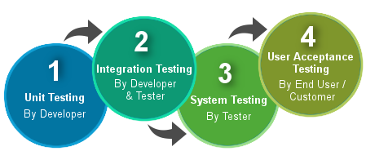
This thorough testing framework ensured that the retail management platform is stable, secure, intuitive, and fully prepared for deployment enhancing operational efficiency and supporting improved customer experience through accurate inventory management and intelligent product recommendations.

Figure 7. Levels of Testing
Unit Testing
System testing evaluated the platform as an integrated solution, ensuring real-time stock tracking, product recommendations, and interface components worked seamlessly. Acceptance testing confirmed compliance with user requirements, while non-functional testing assessed performance, data security, usability, and cross-device compatibility to ensure a reliable and user-friendly retail management system.
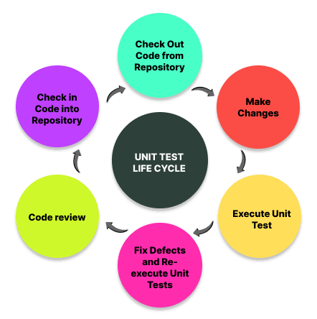
Figure 8. Unit Testing
Integration Testing
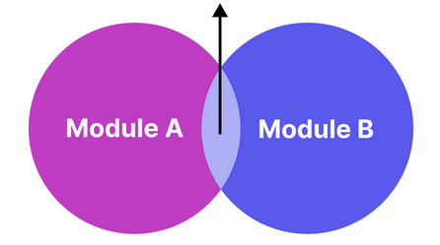
Integration testing verified that core modules—including automated stock monitoring, product management, transaction processing, and the recommendation engine—worked together seamlessly. It validated data flow between the frontend, backend APIs, and database, ensuring accurate synchronization. This phase confirmed that inventory updates, alerts, and recommendation logic functioned correctly, resulting in a stable, unified retail management platform.

Figure 9. Integration Testing

Acceptance Testing
Acceptance testing was conducted to verify that the Retail Management Platform met the operational requirements and expectations of Yophie PC Computer Trading. Key features such as automated stock monitoring, accurate inventory updates, product catalog management, and the personalized recommendation engine were validated. Usability and workflow efficiency were also assessed to ensure smooth navigation for administrators, staff, and customers, confirming the system’s readiness for real-world retail deployment.
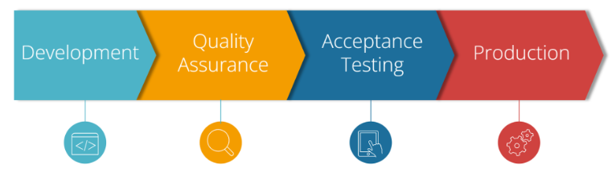
Figure 10. User Acceptance Testing

System Flowchart
The system flowcharts shows how administrators, staff, and customers interact within the Retail Management Platform. Administrators handle product management, update the compatibility matrix, oversee inventory, approve restock requests, and generate reports. Staff members check stock levels, process customer orders, pack items, update inventory, and submit restock requests when needed. Customers browse products, view details, use the compatibility checker, receive recommendations, add items to their cart, and track their orders. Overall, the flowcharts highlight a coordinated workflow that ensures efficient stock monitoring, smooth retail operations, and an improved shopping experience for Yophie PC Computer Trading.
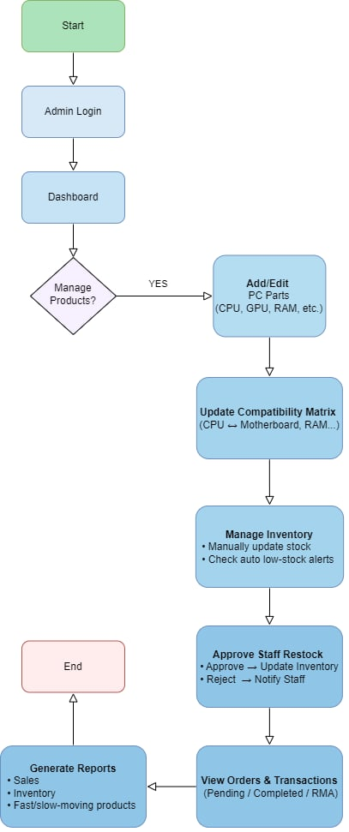

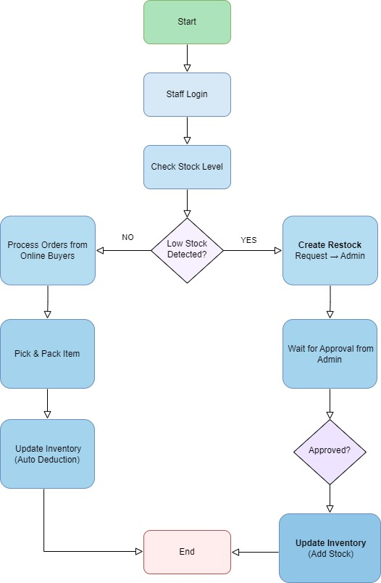
Figure 11. System Flowchart for Administrator

Figure 12. System Flowchart for Staff
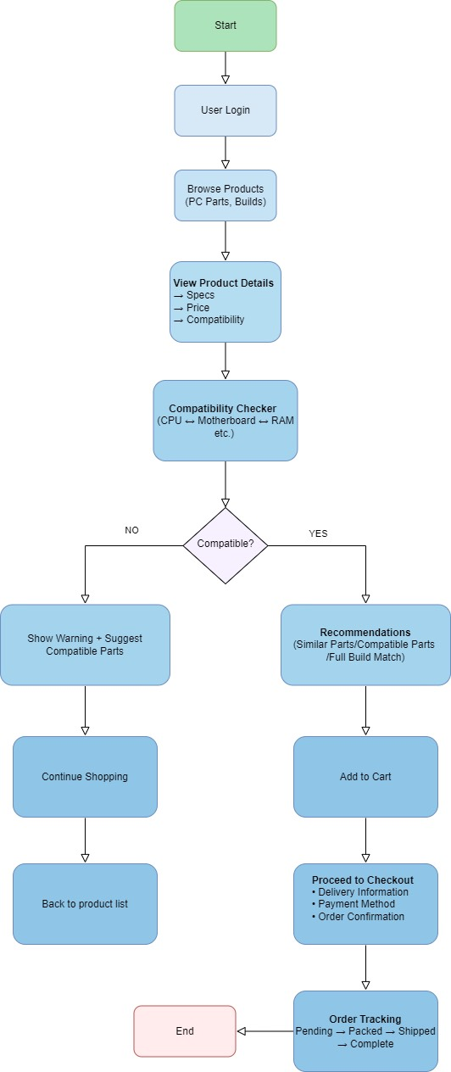

Figure 13. System Flowchart for User
Use Case Diagram
The three use-case diagrams shows how the Administrator, Staff, and Customer work together within the Retail Management Platform. The Administrator oversees the entire system managing products, stock levels, categories, compatibility rules, reports, notifications, and user accounts. Staff members handle daily operations, including checking inventory, processing orders, updating stock, and creating restock requests when needed. Customers browse products, check compatibility, manage their cart, complete purchases, track orders, and update their profiles. Together, these roles ensure efficient store management, accurate stock monitoring, and a smooth, personalized shopping experience.
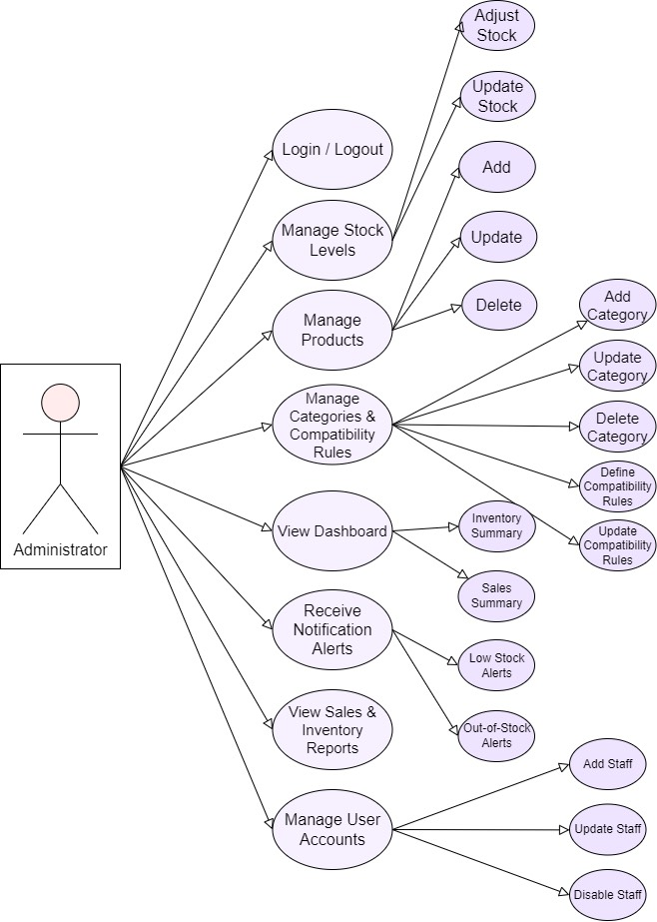

Figure 14. Administrator Use Case Diagram

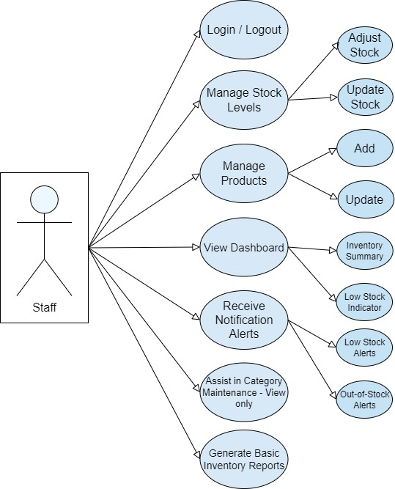

Figure 15. Staff Use Case Diagram
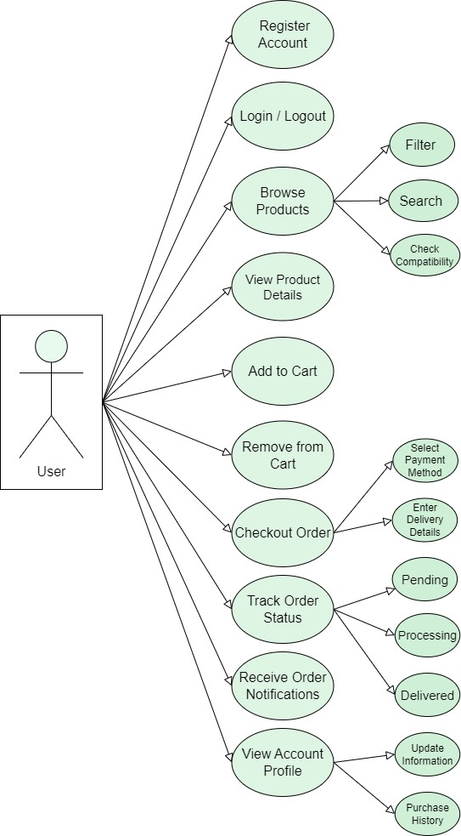

Figure 16. User Use Case Diagram

Evaluation Procedure
For the Retail Management Platform with Intelligent Stock Monitoring and Personalized Product Recommendation System for Yophie PC Computer Trading, beta testing was conducted to assess the system’s usability, efficiency, and overall performance. Using a Likert scale, feedback from staff, IT professionals, and selected customers helped measure how well the platform supported real-time inventory monitoring and delivered accurate product recommendations. The evaluation followed the ISO 25010 software quality standard to ensure a comprehensive assessment.
The testing focused on major ISO 25010 quality attributes such as functional suitability, reliability, usability, performance efficiency, and security. Insights from the evaluation guided improvements in system responsiveness, recommendation accuracy, and inventory update stability. Overall, the ISO 25010 based assessments confirmed that the system meets essential retail operational needs and provides a reliable, user-friendly solution for both administrators and customers.
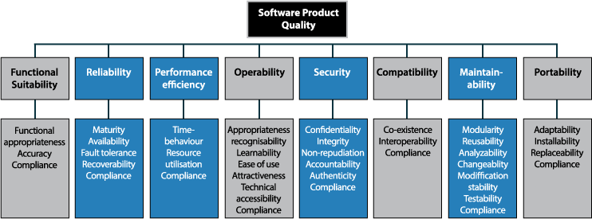

Figure 17. Quality Characteristics of ISO 25010 Standard
Population of the Study
This study on the Retail Management Platform with Intelligent Stock Monitoring and Personalized Product Recommendation System for Yophie PC Computer Trading focused on three primary groups: admin/staff users, customers, and IT experts. These groups represented the key stakeholders who directly interacted with or evaluated the system, ensuring that its features met the practical needs of the business located in Calamba City, Laguna.
Admin and staff users managed day-to-day store operations, including updating product listings, monitoring stock levels, and verifying the accuracy of inventory records. Their participation was essential in evaluating whether the automated stock monitoring and product management features effectively reduced manual workload, minimized errors, and streamlined business processes.
Customers provided insights on the usability and relevance of the personalized product recommendation feature. Their feedback helped determine whether the system successfully enhanced the shopping experience by offering compatibility-based and preference-based suggestions for computer hardware components, making product selection easier and more accurate.
IT experts assessed the technical aspects of the platform, such as system reliability, data security, performance efficiency, and integration between the Vue 3 frontend and the Laravel 10 backend. Their evaluation ensured that the system was stable, scalable, and capable of handling real-time transactions and recommendation logic.
By gathering insights from these three groups admins/staff, customers, and IT professionals the study ensured that the developed retail management platform was functional, secure, user-centered, and highly applicable to the operational requirements of Yophie PC Computer Trading in Calamba City, Laguna.
Table 7. Respondents of the Research Project

 | CATEGORY OF RESPONDENTS | SAMPLE
 | Admin/Staff | 8
 | IT Expert | 7
 | Customers | 25
 | Total | 40

Data Collection Instrument
To evaluate the accuracy, usability, and reliability of the Retail Management Platform with Intelligent Stock Monitoring and Personalized Product Recommendation System for Yophie PC Computer Trading, the researcher utilized structured assessment tools. The primary goal was to determine how effectively the system supported the operational needs of the business by gathering feedback on its performance, ease of use, and overall user satisfaction. This feedback was vital in identifying areas that required refinement and in guiding improvements to key system features, including inventory tracking, product management, and compatibility-based recommendations.
The researchers conducted structured surveys to measure the system’s effectiveness in supporting poultry farmers with environmental monitoring. A 4-point Likert scale was employed to gauge the degree of agreement, eliminating neutral responses to encourage decisive feedback. The survey was handed out as printed questionnaires to collect responses directly from participants, making sure their answers were accurate and reliable.
For analyzing the data, the responses were scored as follows: 1 for Strongly Disagree, 2 for Disagree, 3 for Agree, and 4 for Strongly Agree. The mean score was calculated using the formula:
$$\left(\bar{x}\right)=\frac{\left(Σ \left(f × x\right)\right)}{N}$$
Where f represents the frequency of each response, x is the numerical value assigned to that response, and N is the total number of respondents. This method provided a clear measure of user opinions regarding the system’s effectiveness.
The standard deviation was also calculated to measure the dispersion of responses around the mean, using the formula:
$$s = \sqrt{\frac{Σ{\left(\bar{x}- x\right)}^{2}}{(n-1)}}$$
Where x​ represents each individual response, x is the mean score, and N is the total number of respondents. A lower standard deviation indicates that the responses were closely clustered around the mean, while a higher standard deviation shows more variation in user opinions.
Data encoding and analysis were performed using Microsoft Excel to ensure organized and accurate processing of survey results.

CHAPTER 4

RESULTS AND DISCUSSION
This chapter presents the study’s results, including the analysis and interpretation of the data gathered. The findings are presented through narrative discussions and tabular summaries, supported by appropriate statistical techniques. The results are organized in accordance with the specific objectives stated in Chapter 1 to maintain clarity and logical progression.
The system was designed and implemented as an automated real-time stock monitoring platform that ensures accurate inventory tracking, supports prompt stock updates, and minimizes inventory discrepancies, thereby improving operational efficiency and strengthening inventory reliability.
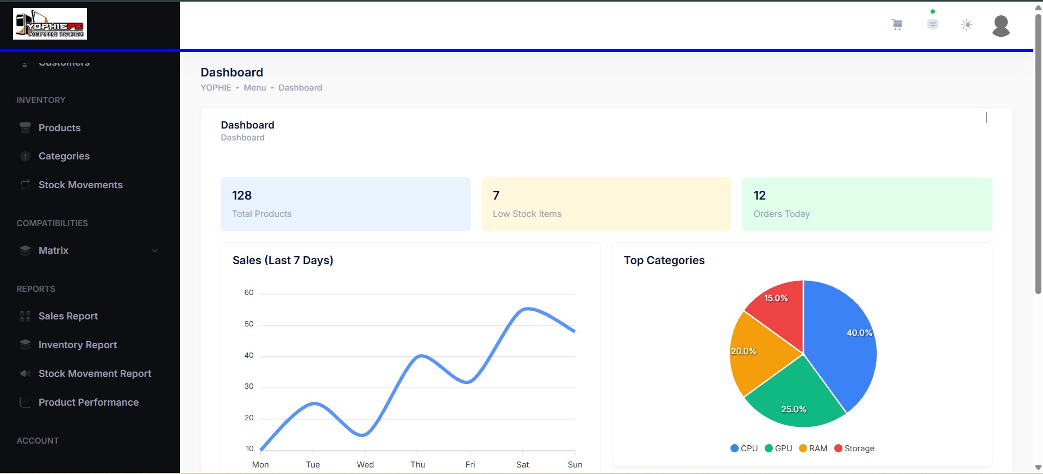
Figure 18. Administrator Dashboard
Figure 18 shows a web-based automated real-time stock monitoring system dashboard. It presents key inventory indicators, including the total number of products (128), low stock items (7), and orders processed today (12), enabling timely and informed decision-making. The dashboard features a line graph that visualizes sales performance over the past seven days, supporting trend analysis and demand forecasting. Additionally, a pie chart illustrates the distribution of top product categories such as CPU, GPU, RAM, and Storage providing insight into inventory allocation. The left-side navigation menu allows users to efficiently access inventory management, reporting, and account-related modules, enhancing system usability and operational efficiency.
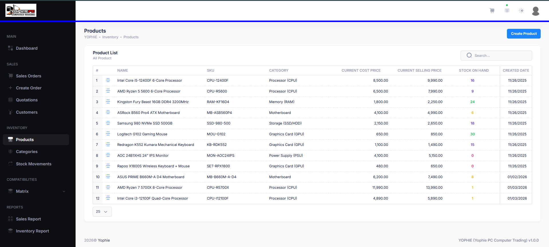
Figure 19. Product Table
Figure 19 shows the Products module of the web-based real-time stock monitoring system, displaying a searchable product list with SKU, category, pricing, and current stock levels to help users track inventory accurately and detect low or out-of-stock items.
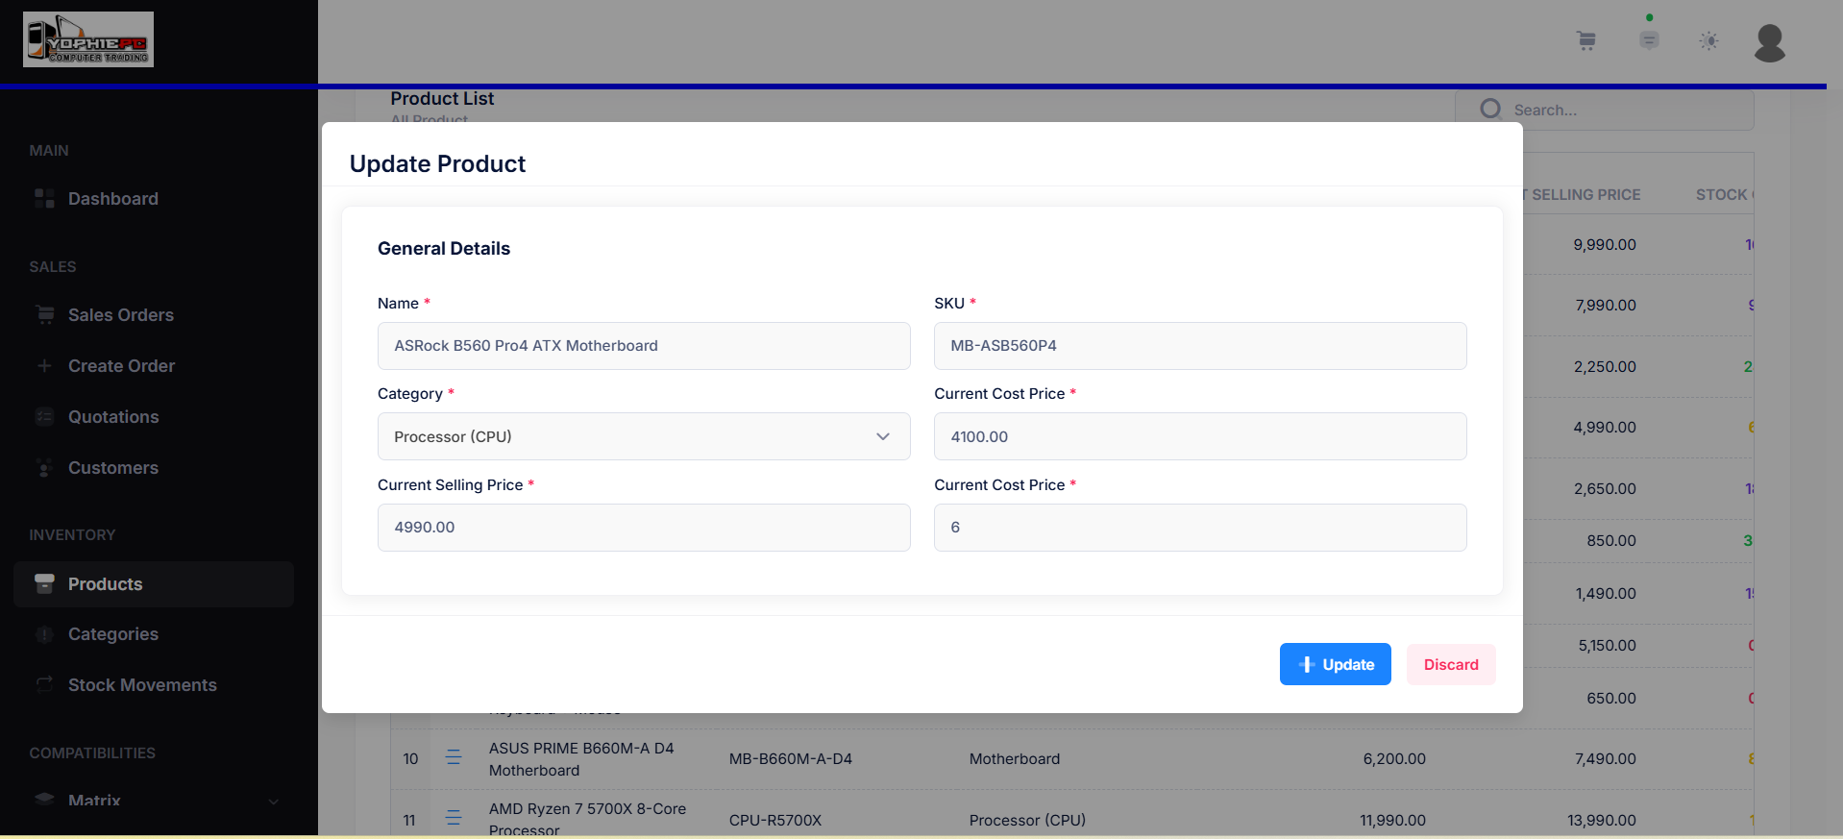
Figure 20. Update Product
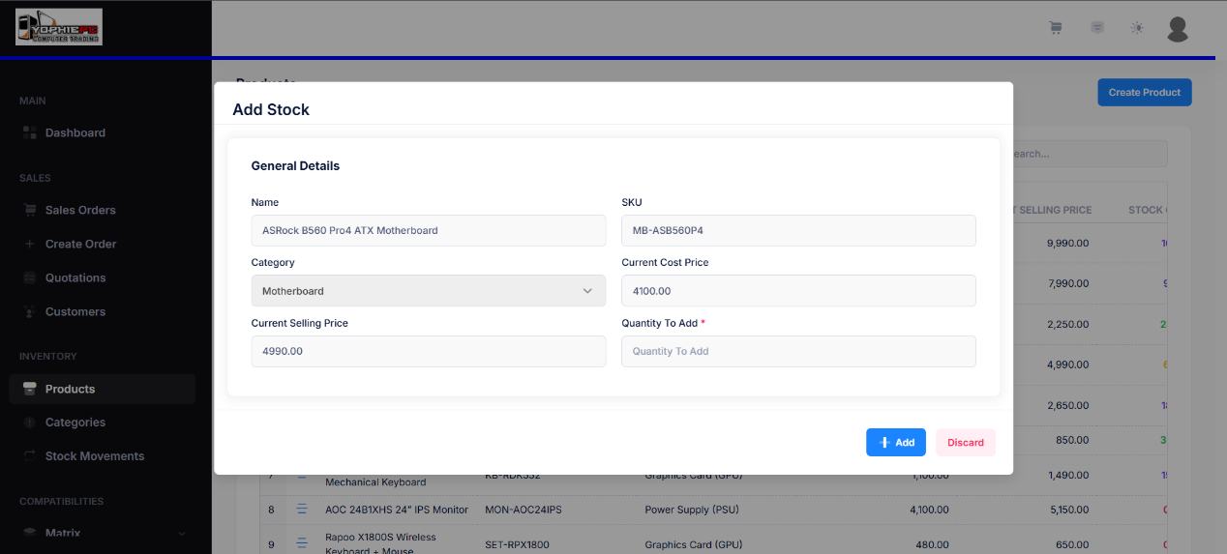
Figure shows the Update Product module of the automated real-time stock monitoring system, allowing authorized users to edit product information such as SKU, category, pricing, and stock quantity. It supports timely and accurate inventory updates by ensuring stock data remains synchronized, reducing reporting delays, and improving responsiveness to sales and stock movements.
Figure 21. Add Product Stock
Figure 21 shows the Add Product Stock interface of the system, where the administrator can update inventory levels by entering the quantity to be added while viewing the product’s essential details such as name, SKU, category, cost price, and selling price. This feature supports accurate and timely stock updates, ensuring that inventory records remain current and consistent. By allowing controlled and validated stock adjustments, the module helps prevent inventory discrepancies such as incorrect stock counts, missing inventory records, and mismatched quantities between system records and actual physical stock, thereby improving inventory reliability and supporting efficient retail operations.
The study developed and integrated a personalized product recommendation feature that considers customer requirements, preferences, and product compatibility to provide accurate and relevant product suggestions, thereby supporting customer decision-making and improving the overall shopping experience.
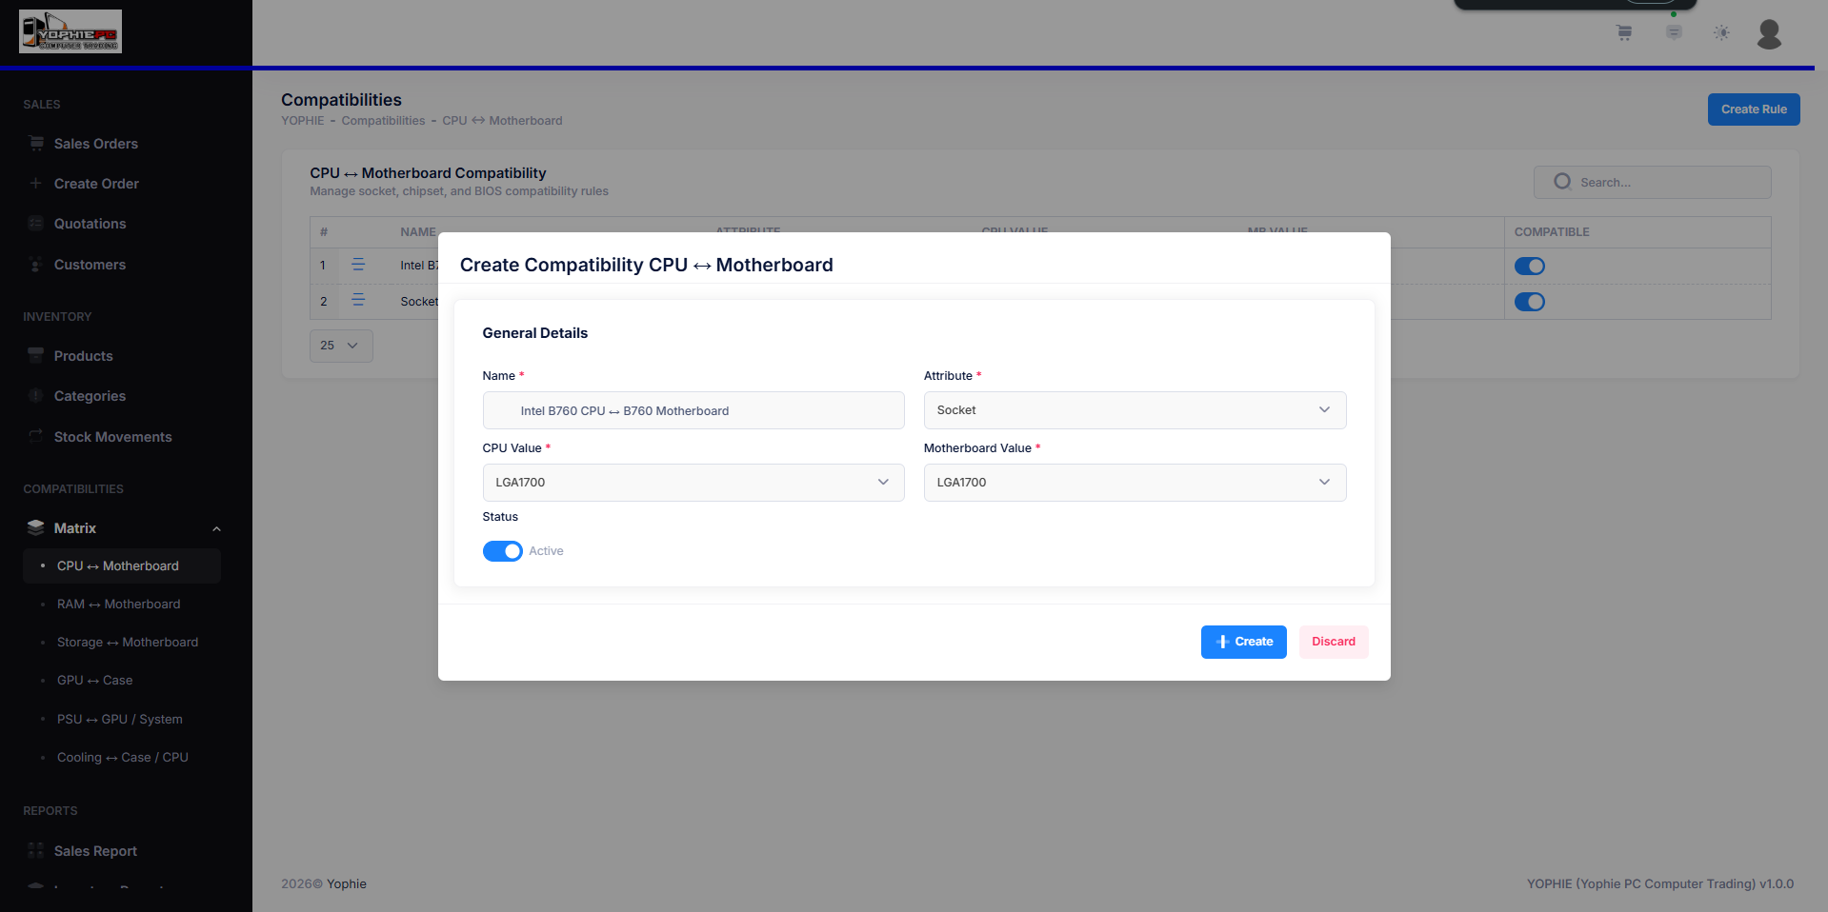
Figure 22. Product Compatibility Matrix
This figure 22 shows the Product Compatibility Matrix interface where the administrator defines CPU–motherboard compatibility rules. This feature ensures that only compatible computer components are recommended, supporting accurate product suggestions and improved customer decision-making.
The developed system was evaluated using the Technology Acceptance Model (TAM) and the ISO 25010 software product quality standards to assess usability, functionality, performance efficiency, and overall quality, thereby validating the system’s effectiveness, reliability, and level of user acceptance.
Evaluation Result using Technology Acceptance Model
Table 8 shows the quality factors of the system as evaluated by the respondents in terms of correctness, reliability, efficiency, and integrity. The results shows that all indicators obtained high mean scores ranging from 3.70 to 3.80, all interpreted as Strongly Agree, indicating a very positive perception of the system’s quality. Among the indicators, Correctness and Reliability recorded the highest mean scores of 3.80 (SD = 0.40 and 0.37, respectively), suggesting that respondents strongly agree that the system provides accurate and up-to-date inventory information and performs consistently during daily retail operations. Integrity also obtained a mean score of 3.80 (SD = 0.43), reflecting strong agreement that user accounts are properly protected through authentication and access control. Meanwhile, Efficiency yielded the lowest mean score of 3.70 (SD = 0.53), although it remains within the Strongly Agree interpretation, indicating that the system effectively helps users complete retail tasks faster, such as stock checking and product selection. Overall, the composite mean of 3.78 with a standard deviation of 0.43 confirms a Strongly Agree rating, implying that respondents generally perceive the system as high quality and reliable.
Table 8. Quality Factors based on Respondents’ Response
INDICATORS | MEAN | SD | INTERPRETATION
- Correctness: The system provides accurate and up-to-date inventory information. | 3.80 | 0.40 | Strongly Agree
- Reliability: The system performs consistently during daily retail operations. | 3.80 | 0.37 | Strongly Agree
- Efficiency: The system helps complete retail tasks faster, such as stock checking and product selection. | 3.70 | 0.53 | Strongly Agree
- Integrity: User accounts are properly protected through authentication and access control. | 3.80 | 0.43 | Strongly Agree
Composite Mean | 3.78 | 0.43 | Strongly Agree
Legend: 1.0-1.75: Strongly Disagree; 1.76-2.50: Disagree; 2.51-3.25: Agree; 3.26-4.0: Strongly Agree
Table 9 shows the respondents perceived ease of use of the system in terms of learnability, understandability, operability, and attractiveness. The findings shows that all indicators obtained high mean scores ranging from 3.70 to 3.80, all interpreted as Strongly Agree, indicating that respondents found the system easy to use. Learnability, Understandability, and Attractiveness recorded the highest mean scores of 3.80 (SD = 0.40), suggesting that respondents strongly agree that the system is easy to learn even for first-time users, that its flow and functions are clear and easy to understand, and that its interface is visually appealing and user-friendly. Meanwhile, Operability obtained a mean score of 3.70 (SD = 0.44), which is still interpreted as Strongly Agree, indicating that the system reduces user effort in managing inventory, products, and transactions. Overall, the composite mean of 3.78 with a standard deviation of 0.41 confirms a Strongly Agree evaluation, signifying that respondents generally perceive the system as highly easy to use.
Table 9. Perceived of Ease Use based on Respondents’ Response
INDICATORS | MEAN | SD | INTERPRETATION
- Learnability: The system is easy to learn, even for first-time users. | 3.80 | 0.40 | Strongly Agree
- Understandability: The system’s flow and functions are clear and easy to understand. | 3.80 | 0.40 | Strongly Agree
- Operability: The system reduces effort in managing inventory, products, and transactions. | 3.70 | 0.44 | Strongly Agree
- Attractiveness: The system interface is visually appealing and user-friendly. | 3.80 | 0.40 | Strongly Agree
Composite Mean | 3.78 | 0.41 | Strongly Agree
Legend: 1.0-1.75: Strongly Disagree; 1.76-2.50: Disagree; 2.51-3.25: Agree; 3.26-4.0: Strongly Agree
Table 10 shows the respondents perceived usefulness of the system in terms of operability, usability, efficiency, and functional completeness. The findings reveal that all indicators obtained high mean scores ranging from 3.67 to 3.80, all interpreted as Strongly Agree, indicating that respondents consider the system highly useful. Operability recorded the highest mean score of 3.80 (SD = 0.37), suggesting that respondents strongly agree that using the system improves their efficiency in performing retail-related tasks. Usability obtained the lowest mean score of 3.67 (SD = 0.47), although it remains within the Strongly Agree range, implying that the automated stock monitoring feature effectively helps prevent inventory discrepancies. Moreover, both Efficiency and Functional Completeness yielded mean scores of 3.70 (SD = 0.44 each), indicating strong agreement that the personalized product recommendation feature helps customers choose compatible products more easily and that the system improves overall store operations. Overall, the composite mean of 3.72 with a standard deviation of 0.43 confirms a Strongly Agree evaluation, signifying that respondents generally perceive the system as highly beneficial and effective.
Table 10. Perceived of Usefulness based on Respondents’ Response
INDICATORS | MEAN | SD | INTERPRETATION
- Operability: Using the system improves my efficiency in performing retail-related tasks. | 3.80 | 0.37 | Strongly Agree
- Usability: The automated stock monitoring helps prevent inventory discrepancies. | 3.67 | 0.47 | Strongly Agree
- Efficiency: The personalized product recommendation feature helps customers choose compatible products more easily. | 3.70 | 0.44 | Strongly Agree
- Functional Completeness: The system improves overall store operations. | 3.70 | 0.44 | Strongly Agree
Composite Mean | 3.72 | 0.43 | Strongly Agree
Legend: 1.0-1.75: Strongly Disagree; 1.76-2.50: Disagree; 2.51-3.25: Agree; 3.26-4.0: Strongly Agree
Table 11 shows the respondents’ attitude toward using the system, focusing on perceived time savings, decision-making support, operational benefits, and user satisfaction. The results shows that all indicators obtained high mean scores ranging from 3.60 to 3.80, all interpreted as Strongly Agree, indicating a highly favorable attitude toward using the system. The indicators with the highest mean scores were the statements that the system improves decision-making for inventory and product selection and that respondents find the system beneficial for daily retail operations, both recording a mean of 3.80 (SD = 0.43). The statement that the system saves time and effort in managing retail activities obtained a mean score of 3.70 (SD = 0.44), reflecting strong agreement regarding its efficiency. Meanwhile, the statement on user confidence and satisfaction recorded the lowest mean score of 3.60 (SD = 0.49), although it still falls under the Strongly Agree interpretation, indicating positive user satisfaction while using the system. Overall, the composite mean of 3.73 with a standard deviation of 0.45 confirms a Strongly Agree evaluation, signifying that respondents demonstrate a positive and supportive attitude toward adopting and using the system.
Table 11. Attitude Towards Using based on Respondents’ Response
INDICATORS | MEAN | SD | INTERPRETATION
- The system saves time and effort in managing retail activities. | 3.70 | 0.44 | Strongly Agree
- The system improves decision-making for inventory and product selection. | 3.80 | 0.43 | Strongly Agree
- I find the system beneficial for daily retail operations. | 3.80 | 0.43 | Strongly Agree
- I feel confident and satisfied using the system as part of regular retail management tasks. | 3.60 | 0.49 | Strongly Agree
Composite Mean | 3.73 | 0.45 | Strongly Agree
Legend: 1.0-1.75: Strongly Disagree; 1.76-2.50: Disagree; 2.51-3.25: Agree; 3.26-4.0: Strongly Agree
Table 12 shows the respondents’ behavioral intention to use the system, as reflected in their willingness to use it regularly, recommend it to others, continue using it if implemented permanently, and participate in future system improvements. The results shows that all indicators obtained high mean scores ranging from 3.70 to 3.80, all interpreted as Strongly Agree, indicating a strong intention among respondents to adopt and continue using the system. The highest mean scores were recorded for the statements “I am willing to use this system regularly” and “I am open to participating in future system improvements,” both with a mean of 3.80 (SD = 0.43 and 0.48, respectively), suggesting a strong commitment to system usage and involvement in future enhancements. Meanwhile, the indicators “I am willing to recommend this system to others” and “I am willing to continue using the system if implemented permanently” both obtained mean scores of 3.70 (SD = 0.44), indicating positive endorsement and willingness for long-term use. Overall, the composite mean of 3.75 with a standard deviation of 0.45 confirms a Strongly Agree evaluation, demonstrating high system acceptance and strong behavioral intention to use the system.
Table 12. Behavioral Intention to Use based on Respondents’ Response
INDICATORS | MEAN | SD | INTERPRETATION
- I am willing to use this system regularly. | 3.80 | 0.43 | Strongly Agree
- I am willing to recommend this system to others. | 3.70 | 0.44 | Strongly Agree
- I am willing to continue using the system if implemented permanently. | 3.70 | 0.44 | Strongly Agree
- I am open to participating in future system improvements. | 3.80 | 0.48 | Strongly Agree
Composite Mean | 3.75 | 0.45 | Strongly Agree
Legend: 1.0-1.75: Strongly Disagree; 1.76-2.50: Disagree; 2.51-3.25: Agree; 3.26-4.0: Strongly Agree
Table 13 shows the respondents’ overall experience in using the system in terms of ease of navigation, system reliability, operational convenience, and enhancement of the shopping and management experience. The results reveal that all indicators obtained high mean scores ranging from 3.60 to 3.80, all interpreted as Strongly Agree, indicating a highly positive user experience. The highest mean score (3.80) shows that respondents can easily navigate and use the system for their assigned tasks. Similarly, respondents strongly agreed that the system makes retail operations smoother and more convenient (mean = 3.80) and enhances the overall shopping and management experience (mean = 3.80). Meanwhile, the indicator on system reliability (“rarely experience errors”) obtained the lowest mean score of 3.60 with an SD of 0.56, although it still falls under the Strongly Agree interpretation, reflecting dependable system performance. Overall, the composite mean of 3.75 with a standard deviation of 0.46 confirms a Strongly Agree evaluation, indicating that respondents had a highly favorable experience while using the system.
Table 13. Experience based on Respondents’ Response
INDICATORS | MEAN | SD | INTERPRETATION
- I can easily navigate and use the system for my assigned tasks. | 3.80 | 0.43 | Strongly Agree
- I rarely experience errors while using the system. | 3.60 | 0.56 | Strongly Agree
- The system makes retail operations smoother and more convenient. | 3.80 | 0.43 | Strongly Agree
- The system enhances the overall shopping and management experience. | 3.80 | 0.43 | Strongly Agree
Composite Mean | 3.75 | 0.46 | Strongly Agree
Legend: 1.0-1.75: Strongly Disagree; 1.76-2.50: Disagree; 2.51-3.25: Agree; 3.26-4.0: Strongly Agree
Table 14 shows the summary results of the Technology Acceptance Model (TAM) based on the respondents’ responses across key evaluation indicators. The results shows that all indicators obtained mean scores within the Strongly Agree range, indicating a high level of system acceptance among respondents. Quality Factors and Perceived Ease of Use recorded the highest mean scores of 3.78 (SD = 0.43 and 0.41, respectively), reflecting strong agreement regarding the system’s overall quality and ease of use. Perceived Usefulness yielded a mean of 3.72 (SD = 0.43), suggesting that respondents strongly agree that the system effectively supports their tasks and improves operational performance. In addition, Attitude Towards Using obtained a mean score of 3.73 (SD = 0.45), indicating a positive perception toward using the system. Both Behavioral Intention to Use and Experience posted mean scores of 3.75 (SD = 0.45 and 0.46, respectively), signifying strong willingness to continue using the system and positive user experiences during interaction. Overall, the overall mean of 3.75 with a standard deviation of 0.44 confirms a Strongly Agree interpretation, implying that respondents generally demonstrate strong acceptance and readiness to adopt the system.
Table 14. Result of Technology Acceptance Model based on Response
INDICATORS | MEAN | SD | INTERPRETATION
Quality Factors | 3.78 | 0.43 | Strongly Agree
Perceived Ease of Use | 3.78 | 0.41 | Strongly Agree
Perceived Usefulness | 3.72 | 0.43 | Strongly Agree
Attitude Towards Using | 3.73 | 0.45 | Strongly Agree
Behavioral Intention to Use | 3.75 | 0.45 | Strongly Agree
Experience | 3.75 | 0.46 | Strongly Agree
Overall Mean | 3.75 | 0.44 | Strongly Agree
Legend: 1.0-1.75: Strongly Disagree; 1.76-2.50: Disagree; 2.51-3.25: Agree; 3.26-4.0: Strongly Agree
Test and Evaluate the Software using ISO 25010
Table 15 shows the evaluation of the system’s functional suitability based on the responses of IT specialists, focusing on functional completeness, functional correctness, and functional appropriateness. The results shows that Functional Completeness obtained the highest mean score of 4.00 (SD = 0.00), interpreted as Strongly Agree, indicating that the system fully supports essential retail operations such as real-time stock monitoring, product management, transaction recording, and personalized product recommendations. Likewise, Functional Correctness recorded a mean of 4.00 (SD = 0.00) with a Strongly Agree interpretation, reflecting that the system provides accurate inventory data, correct product information, and reliable compatibility-based recommendations. Meanwhile, Functional Appropriateness obtained a mean score of 3.33 (SD = 0.57), also interpreted as Strongly Agree, suggesting that the system effectively supports key retail tasks such as inventory tracking, product browsing, and decision-making.
Table 15. Functional Suitability based on IT Specialist Response
INDICATORS | MEAN | INTERPRETATION
- Functional Completeness – The system covers all essential retail operations, including real-time stock monitoring, product management, transaction recording, and personalized product recommendations. | 4 | Strongly Agree
- Functional Correctness – The system provides accurate inventory data, correct product details, and reliable compatibility-based recommendations for computer hardware components. | 4 | Strongly Agree
- Functional Appropriateness – The system effectively supports retail tasks such as inventory tracking, product browsing, and decision-making, enabling users to accomplish their objectives efficiently. | 3.33 | Strongly Agree
Composite Mean | 3.78 | Strongly Agree
Legend: 1.0-1.75: Strongly Disagree; 1.76-2.50: Disagree; 2.51-3.25: Agree; 3.26-4.0: Strongly Agree
Table 16 shows the assessment of the system’s reliability based on the responses of IT specialists, focusing on maturity, availability, fault tolerance, and recoverability. The findings shows that all reliability indicators were rated within the Strongly Agree range, reflecting a high level of confidence in the system’s dependable performance. Availability and Recoverability recorded the highest mean scores of 4.00 (SD = 0.00), indicating that the platform remains accessible during business hours and that data is preserved, allowing operations to resume without loss of critical inventory or transaction records in the event of interruptions. Meanwhile, Maturity and Fault Tolerance obtained mean scores of 3.33 (SD = 0.57), suggesting that the system operates consistently during regular use with minimal errors and can handle minor issues such as invalid inputs or connection problems without disrupting overall operations.
Table 16. Reliability based on IT Specialist Response
INDICATORS | MEAN | INTERPRETATION
- Maturity – The system operates consistently during regular use, with minimal errors encountered during testing and deployment. | 3.33 | Strongly Agree
- Availability – The platform remains accessible to users during business hours, allowing continuous monitoring of stock levels and transactions. | 4 | Strongly Agree
- Fault Tolerance - The system handles minor errors, such as invalid inputs or connection issues, without disrupting overall operations.  - Recoverability – In the event of system interruption, data is preserved and operations can resume without loss of critical inventory or transaction records. | 3.33  4 | Strongly Agree  Strongly Agree
Composite Mean | 3.67 | Strongly Agree
Legend: 1.0-1.75: Strongly Disagree; 1.76-2.50: Disagree; 2.51-3.25: Agree; 3.26-4.0: Strongly Agree
Table 17 shows the evaluation of the system’s performance efficiency based on the responses of IT specialists, focusing on response time, throughput, resource utilization, scalability, and load handling. The results shows that all indicators were rated within the Strongly Agree range, indicating strong confidence in the system’s efficiency and performance. Throughput, Resource Utilization, Scalability, and Load Handling recorded the highest mean scores of 4.00 (SD = 0.00), suggesting that the platform can support multiple users simultaneously, efficiently utilize system resources, scale as business demands increase, and maintain reliable performance even during peak usage periods. Meanwhile, Response Time obtained a mean score of 3.33 (SD = 0.57), which is still interpreted as Strongly Agree, indicating that the system responds quickly to user actions such as product searches, stock updates, and recommendation generation.

Table 17. Performance Efficiency on IT Specialist Response
INDICATORS | MEAN | INTERPRETATION
- Response Time – The system responds quickly to user actions, including product searches, stock updates, and recommendation generation. | 3.33 | Strongly Agree
- Throughput – The platform supports multiple users simultaneously without noticeable performance degradation. | 4 | Strongly Agree
- Resource Utilization - System resources such as memory and processing power are efficiently utilized to maintain stable performance.  - Scalability – The system can accommodate increasing numbers of products, transactions, and users as the business grows.  - Load Handling - The platform performs reliably even during peak usage periods, such as high transaction volumes or multiple concurrent searches. | 4  4  4 | Strongly Agree  Strongly Agree  Strongly Agree
Composite Mean | 3.87 | Strongly Agree
Legend: 1.0-1.75: Strongly Disagree; 1.76-2.50: Disagree; 2.51-3.25: Agree; 3.26-4.0: Strongly Agree
Table 18 shows the evaluation of the system’s operability based on the responses of IT specialists, covering appropriateness recognizability, learnability, operability, user error protection, user interface aesthetics, and accessibility. The results shows that all indicators were rated within the Strongly Agree range, reflecting a high level of confidence in the system’s usability and ease of operation. Learnability, User Error Protection, User Interface Aesthetics, and Accessibility recorded the highest mean scores of 4.00 (SD = 0.00), indicating that new users can learn the system with minimal training, common user errors are effectively prevented, the interface is clean and visually appealing, and tasks can be performed efficiently across supported devices. Meanwhile, Appropriateness Recognizability obtained a mean score of 3.66 (SD = 0.57), suggesting that users can easily recognize that the system is suitable for managing retail operations. Operability recorded the lowest mean score of 3.33 (SD = 0.57), but it remains interpreted as Strongly Agree, indicating that the system can still be operated smoothly with minimal effort from administrators, staff, and customers. Overall, the composite mean of 3.83 with a standard deviation of 0.19 confirms a Strongly Agree evaluation, demonstrating that the system is highly operable and user-friendly.
Table 18. Operability on IT Specialist Response
INDICATORS | MEAN | INTERPRETATION
- Appropriateness Recognizability – Users can easily determine that the system is suitable for managing retail operations. | 3.66 | Strongly Agree
- Learnability – New users can learn how to use the system with minimal training. | 4 | Strongly Agree
- Operability - The system can be operated smoothly with minimal effort from administrators, staff, and customers.  - User error protection – The system helps prevent common user errors, such as invalid stock updates or incorrect product entries.  - User interface aesthetics - The interface provides a clean, organized, and visually appealing layout that enhances user experience.  - Accessibility - The system allows users to accomplish tasks efficiently across supported devices. | 3.33  4  4  4 | Strongly Agree  Strongly Agree  Strongly Agree  Strongly Agree
Composite Mean | 3.83 | Strongly Agree
Legend: 1.0-1.75: Strongly Disagree; 1.76-2.50: Disagree; 2.51-3.25: Agree; 3.26-4.0: Strongly Agree
Table 19 shows the assessment of the system’s security based on the responses of IT specialists, with emphasis on confidentiality and integrity as key security characteristics. The results shows that both indicators were rated within the Strongly Agree range, reflecting a high level of confidence in the system’s security mechanisms. Confidentiality obtained the highest mean score of 4.00 (SD = 0.00), indicating strong agreement that user accounts, inventory data, and transaction records are accessible only to authorized users, thereby reducing the risk of unauthorized access and potential data breaches. Meanwhile, Integrity recorded a mean score of 3.66 (SD = 0.57), also interpreted as Strongly Agree, suggesting that the system effectively protects data from unauthorized modification and maintains the accuracy and reliability of inventory and transaction information. Overall, the composite mean of 3.83 with a standard deviation of 0.29 confirms a Strongly Agree evaluation, indicating that IT specialists generally perceive the system as secure and capable of safeguarding sensitive operational data within the retail environment.
Table 19. Security on IT Specialist Response
INDICATORS | MEAN | INTERPRETATION
- Confidentiality – User accounts, inventory data, and transaction records are accessible only to authorized users. | 4 | Strongly Agree
- Integrity – The system protects data from unauthorized modification and maintains the accuracy of inventory and transaction information. | 3.66 | Strongly Agree
Composite Mean | 3.83 | Strongly Agree
Legend: 1.0-1.75: Strongly Disagree; 1.76-2.50: Disagree; 2.51-3.25: Agree; 3.26-4.0: Strongly Agree
This Table 20 indicates that IT specialists strongly agree that the system demonstrates excellent compatibility, particularly in co-existence and interoperability. The results show that the platform operates smoothly alongside existing software without conflicts or disruptions, ensuring stable performance within the current environment. In addition, effective communication across the system’s core components highlights strong interoperability and seamless data exchange. The high composite mean reflects strong system integration, reliability, and consistency in overall operation. Overall, expert evaluation and testing results confirm that the system is well-integrated, highly compatible, and capable of functioning efficiently and seamlessly within the organization’s existing technical infrastructure and operational environment.

Table 20. Compatibility on IT Specialist Response
INDICATORS | MEAN | INTERPRETATION
- Co-existence – The system operates alongside existing software and tools used by the business without conflict. | 3.66 | Strongly Agree
- Interoperability – The platform communicates effectively between the frontend (Vue 3), backend (Laravel 10), and the MySQL database. | 4 | Strongly Agree
Composite Mean | 3.83 | Strongly Agree
Legend: 1.0-1.75: Strongly Disagree; 1.76-2.50: Disagree; 2.51-3.25: Agree; 3.26-4.0: Strongly Agree
Table 21 shows that IT specialists rated the system’s maintainability indicators (modularity, reusability, analyzability, modifiability, and testability) as Strongly Agree, with perfect scores of 4.00 (SD = 0.00). This indicates that the system is well-structured, easy to maintain and update, reusable for future enhancements, and easy to analyze, modify, and test for long-term sustainability.
Table 21. Maintainability on IT Specialist Response
INDICATORS | MEAN | INTERPRETATION
- Modularity – The system is composed of separate modules (inventory, product management, recommendations, users), allowing updates without affecting other components. | 4 | Strongly Agree
- Reusability – System components can be reused or extended for future enhancements or similar retail applications. | 4 | Strongly Agree
- Analyzability - System errors and performance issues can be identified and diagnosed quickly.  - Modifiability – The system can be efficiently updated to accommodate new features or changes in business requirements.  - Testability - Clear test criteria are established, allowing the system to be tested effectively before deployment. | 4  4  4 | Strongly Agree  Strongly Agree  Strongly Agree
Composite Mean | 4 | Strongly Agree
Legend: 1.0-1.75: Strongly Disagree; 1.76-2.50: Disagree; 2.51-3.25: Agree; 3.26-4.0: Strongly Agree

Table 22 shows the ISO 25010 evaluation results from IT specialists, showing that all quality indicators were rated “Strongly Agree,” reflecting high technical acceptance and compliance with ISO standards. Maintainability obtained the highest mean score (4.00), followed by Performance Efficiency (3.87). Operability, Security, and Compatibility each scored 3.83, indicating the system is user-friendly, secure, and compatible. The overall mean of 3.83 confirms the system is robust and reliable.
Table 22. Result of ISO 25010 based on IT Specialist Response
INDICATORS | MEAN | INTERPRETATION
Functional Suitability | 3.78 | Strongly Agree
Maturity | 3.67 | Strongly Agree
Performance  Efficiency | 3.87 | Strongly Agree
Operability | 3.83 | Strongly Agree
Security | 3.83 | Strongly Agree
Compatibility | 3.83 | Strongly Agree
Maintainability | 4 | Strongly Agree
Overall Mean | 3.83 | Strongly Agree
Legend: 1.0-1.75: Strongly Disagree; 1.76-2.50: Disagree; 2.51-3.25: Agree; 3.26-4.0: Strongly Agree
Result of Software Testing
Table 23 shows the unit testing results of the Retail Management Platform across major features such as authentication, inventory, recommendations, transactions, reports, and system settings. Most functions worked as expected, and initial issues (e.g., validation errors, input formats, rule adjustments, and notification delays) were resolved through fixes and retesting. All modules passed after corrections, with response times of 1–2 seconds, confirming that the system is stable, responsive, and ready for deployment.
Table 23. Unit Testing for Retail Management Platform
FEATURE TESTED | PERFORMANCE RESULT | RESPONSE TIME | NO. OF TEST RUNS | REMARKS
User Authentication (Login/Logout)  Dashboard Display  Product Catalog Module  Inventory Management Module  Product Recommendation Module  Transaction Record  Notification & Alerts  Reports & Analytics | Initial test failed due to incorrect credential validation; fixed and passed in subsequent runs.  Stock levels, alerts, and summaries displayed correctly; minor UI delay resolved.  Product details (specs, categories, compatibility) loaded correctly; one input validation issue fixed. Stock updates reflected accurately; one test repeated due to incorrect quantity format.  Compatibility-based recommendations generated correctly; first run required rule adjustment.  Sales and inventory transactions recorded successfully; timestamps verified. Low-stock and out-of-stock alerts triggered correctly; slight delay on first SMS alert resolved.  Sales and inventory reports generated accurately; charts rendered correctly. | 1 second  1.5 seconds  1.8 seconds  1.6 seconds  2 seconds  1.7 seconds  2 seconds  1.9 seconds | 4 runs (1 failed, 3 passed)  3 runs (all passed)  4 runs (1 failed, 3 passed  3 runs (all passed)  4 runs (1 failed, 3 passed)  3 runs (all passed)  4 runs (1 delayed, 3 passed)  3 runs (all passed) | Passed after fix  Passed  Passed after fix  Passed  Passed after retest  Passed  Passed  Passed

Integration Testing Result
Table 24 shows the integration testing results of the Retail Management Platform, confirming that all major system modules functioned correctly when working together. The frontend and backend components were successfully integrated, enabling accurate real-time display and processing of product, inventory, and recommendation data across the platform. This ensured smooth data flow and consistent system behavior during operations.
Furthermore, inventory updates synchronized properly across modules, transactions triggered correct stock deductions, and automated low-stock notifications functioned as expected. Role-based access control was also validated, ensuring secure user permissions. With response times ranging from 1.2 to 2.0 seconds, all components passed multiple test runs, confirming reliable, efficient, and well-coordinated system integration suitable for real-world deployment.
Table 24. Integration Testing for Retail Management Platform
FEATURE  TESTED | INTENDED  FUNCTIONALITY | PERFORMANCE  RESULT | RESPONSE TIME | NUMBER OF TESTS | REMARKS
Web-Based System  (Frontend-Backend Integration)  Inventory Management Module  Product Recommendation Engine  Transaction and Inventory Linkage  Notification System  User Authentication and Access Control | The web application should display real-time product data, stock levels, and recommendations retrieved from the backend.  The system should synchronize product stock updates between staff actions and the database.  The system should generate compatibility-based and personalized product recommendations.  Sales transactions should automatically update inventory levels.  The system should send alerts for low-stock and out-of-stock products.  The system should enforce role-based access for admin and staff users. | The system successfully displayed updated inventory data and recommendation results on the dashboard without errors.  Inventory changes (add, update, deduct) were reflected accurately across the system in real time.  Compatibility-based recommendations were generated correctly; initial test required rule adjustment but passed after refinement.  Completed transactions correctly triggered automatic stock deduction without data mismatch.  Low-stock alerts were triggered and displayed correctly based on predefined thresholds.  Admin and staff permissions were correctly enforced across all integrated modules. | 1.5 seconds  1.6 seconds  1.8 seconds  1.7 seconds  2.0 seconds  1.2 seconds | 10 test runs  12 test runs  10 test runs  15 test runs  8 alert tests  10 login tests | Passed  Passed  Passed after adjustment  Passed  Passed  Passed

Result of Stress Test
Table 25 shows the stress testing results of the Retail Management Platform, showing that the system remained reliable under demanding conditions. It processed transaction volumes while maintaining accurate stock deductions and consistent performance. The platform handled large datasets, including products, transactions, and recommendations, without data loss or slowdown. During network interruptions, updates were delayed and synchronized upon reconnection, preserving data integrity. Automated low- and out-of-stock alerts worked correctly, and concurrent access by administrators, staff, and customers was supported without performance degradation.
Table 25. Stress Testing Result for Retail Management Platform
TEST ID | STEPS | EXPECTED RESULTS | ACTUAL RESULTS | REMARKS
1  2  3  4  5 | High Transaction Load Test (System Reliability)  Full Load Stress Test (Data Processing)  High Transaction Load Test (System Reliability) Network Interruption Test (System Resilience)  Abnormal Stock Scenario Test (Alert System)  Concurrent User Access Test (Performance Efficiency) | The system should process multiple simultaneous sales transactions without inventory mismatch or system slowdown.  The system should handle a large number of product records, transactions, and recommendation requests simultaneously without data loss.  If network connectivity is interrupted, the system should prevent data inconsistency and resume operations once reconnected.  When stock levels drop below the defined threshold, the system should automatically trigger low-stock or out-of-stock alerts.  The system should support simultaneous access by admins, staff, and customers without performance degradation. | The system successfully processed concurrent transactions while maintaining accurate stock deductions and stable performance.  All transactions, inventory updates, and recommendation outputs were processed and stored correctly with no data corruption observed.  The system temporarily delayed updates during disconnection and successfully synchronized data upon reconnection without duplication or loss.  Alerts were generated and displayed promptly, and notification logic functioned correctly under stress conditions.  The platform maintained responsive performance while handling multiple user sessions and operations concurrently. | Passed  Passed  Passed  Passed  Passed

CHAPTER 5

SUMMARY, CONCLUSIONS AND RECOMMENDATIONS
This chapter presents a summary of the study’s key findings and discusses their significance. It also connects the results to the research objectives and problems stated in the introduction. In addition, this chapter provides recommendations based on the findings and encourages future researchers to explore specific areas related to the study for further investigation.
Summary
This study focused on the design, development, and evaluation of a Retail Management Platform with Intelligent Stock Monitoring and Personalized Product Recommendation System for Yophie PC Computer Trading in Calamba City, Laguna. The system was developed to address common challenges in retail operations, particularly inventory discrepancies, manual stock tracking, and the lack of intelligent product recommendations for customers.
The platform integrates real-time stock monitoring, automated alerts for low-stock and out-of-stock items, and a personalized recommendation feature that suggests compatible computer components based on customer needs and preferences. The system was implemented using a Vue 3 frontend, a Laravel 10 backend, and a MySQL centralized database, following an Evolutionary Prototyping / Agile-based development approach.
To evaluate the system’s effectiveness and quality, the study applied the Technology Acceptance Model (TAM) and ISO/IEC 25010 software product quality standards. Data were gathered from administrators, staff, customers, and IT experts using a 4-point Likert scale questionnaire. Results from functional, integration, and stress testing further validated the reliability, accuracy, and performance of the system.
Conclusion
Accurate and Real-Time Stock Monitoring
The developed system successfully provided accurate, real-time inventory tracking. Automated stock updates, low-stock alerts, and inventory validation mechanisms significantly reduced inventory discrepancies and minimized manual errors. This confirms that the first objective to design a system that prevents inventory discrepancies through real-time stock monitoring was achieved.
Effective Personalized Product Recommendation Feature
The product recommendation module effectively generated compatibility-based and preference-driven suggestions for customers. By analyzing product attributes and compatibility rules (e.g., CPU–motherboard–RAM), the system improved product selection accuracy and enhanced the overall shopping experience. This satisfies the second objective of developing a personalized recommendation feature.
High User Acceptance and Software Quality Compliance
Evaluation results using the Technology Acceptance Model indicated high levels of perceived usefulness, ease of use, and positive attitude toward system usage. Likewise, assessment based on ISO/IEC 25010 demonstrated that the system met key quality characteristics such as functionality, performance efficiency, usability, reliability, security, and maintainability. These results confirm that the third objective to test and evaluate the system using TAM and ISO 25010 was successfully met.
Recommendations
The Retail Management Platform with Automated Stock Monitoring and Personalized Product Recommendation System successfully met its objectives and demonstrated effective performance based on the results and evaluations conducted. However, further enhancements can be introduced to improve the system’s functionality, scalability, and long-term sustainability. The following recommendations are proposed:
- Integrate Advanced Analytics and Demand Forecasting for future versions of the system may incorporate predictive analytics or machine learning-based demand forecasting to anticipate product demand trends. This enhancement can help administrators plan restocking schedules more efficiently, reduce overstocking or stock shortages, and improve inventory turnover.
- Enhance the Recommendation Engine with Customer Behavior Analysis for personalized product recommendation feature can be further improved by incorporating deeper customer behavior data such as purchase history, browsing duration, and frequently viewed items. This would allow the system to generate more accurate, preference-based, and context-aware recommendations, further enhancing the customer shopping experience.
- Implement Multi-Channel Notifications in addition to system alerts, future development may include email, SMS, or mobile push notifications for low-stock alerts, order updates, and promotional announcements. This will ensure timely communication for administrators, staff, and customers, improving responsiveness and engagement.
- Develop a Mobile Application Version to create a mobile-friendly or dedicated mobile application version of the platform would allow administrators and staff to monitor inventory, approve restock requests, and receive alerts anytime and anywhere. This improves accessibility and operational flexibility, especially during off-site management.
- Strengthen Security and Backup Mechanisms to enhance system reliability and data protection, future implementations should include automated database backups, advanced role-based access control, and additional security layers such as two-factor authentication. These measures will help protect sensitive transaction and inventory data while ensuring business continuity.

REFERENCES
Anirudh, P. (2023). The evolution of financial decision support systems: From
BI dashboards to predictive analytics. KOS Journal of Business Management, 1(1), 1–8.

Anirudh, P. (2023). The evolution of financial decision support systems: From
BI dashboards to predictive analytics. KOS Journal of Business Management, 1(1), 1–8.

Bektemyssova, G., Guldana, S., & Yerassyl, A. (2024). Application of
recommended systems for e-commerce. Procedia Computer Science, 228, 212–219. https://doi.org/10.1016/j.procs.2023.12.212

Blancaflor, E., Nora, A., & Zacarias, J. C. (2022). A web-based customer
relationship management system designed for event services: B2C e-commerce platform. In Proceedings of the 10th International Conference on Computer and Communications Management (pp. 283–289). https://doi.org/10.1145/3556223.3556266

Crespi, E., Brown, J. L., Huynh, N. B. C., Bautista, M. A., Bacar, C. G. V.,
Bacar, F. V., & Cohen, J. E. (2025).
Industry strategies for attracting youth to cigarettes, e-cigarettes, and HTPs: Retailer density and marketing at points-of-sale in Vietnam and the Philippines. Asian Pacific Journal of Cancer Prevention, 26(4), 1253–1259. https://doi.org/10.31557/APJCP.2025.26.4.1253

Filani, O. M., Nwokocha, G. C., & Alao, O. B. (2022). Vendor performance
analytics dashboard enabling real-time decision-making through integrated procurement, quality, and cost metrics. SHISRRJ, 5(6), 311–318. https://doi.org/10.32628/SHISRRJ

Guillen, N. B., Jr. (2023). Retail marketing competencies in an omnichannel
world: A post-pandemic shopping revolution. SEISENSE Business Review, 3(1), 76–94. https://doi.org/10.33215/2gfqxs61

Ha, A. Y., Luo, H., & Shang, W. (2022). Supplier encroachment, information
sharing, and channel structure in online retail platforms. Production and Operations Management, 31(3), 13607. https://doi.org/10.1111/poms.13607

Hagen, D., Spierings, B., Weltevreden, J., Risselada, A., & Atzema, O.
(2023). What drives consumers to use local online retail platforms? The influence of motives. Journal of Retailing and Consumer Services, 75, 103649. https://doi.org/10.1016/j.jretconser.2023.103649

Halstian, N. (2025). Use of digital tools for sales management in the retail
business. Emerging Frontiers Library for The American Journal of Management and Economics Innovations, 7(7), 33–41.

Hussien, F. T. A., Rahma, A. M. S., & Abdul Wahab, H. B. (2021).
Recommendation systems for e-commerce systems: An overview. Journal of Physics: Conference Series, 1897, 012024. https://doi.org/10.1088/1742-6596/1897/1/012024

Jacob, D. M. (2024). Adoption of cashless payments by retail enterprises in
Legazpi City. Journal of Interdisciplinary Perspectives, 2(9), 312–322. https://doi.org/10.69569/jip.2024.0391.

Ligot, D. V., Melendres, R. L., Tayco, F. C., Vizmonte, E. J., Toledo, M.,
Gerlock-Barretto, A., … Neri, C. (2022). Philippines data analytics sector labor market intelligence report. SSRN Electronic Journal. https://doi.org/10.2139/ssrn.4027384

Madamidola, O. A., Daramola, O. A., Akintola, K. G., & Adeboje, O. T. (2024).
A review of existing inventory management systems. International Journal of Research in Engineering and Science, 12(9), 40–50.

Mahmud, D., & Ikbal, M. Z. (2024).Power BI and data analytics in financial
reporting: A review of real-time dashboarding and predictive BI tools. International Journal of Scientific Interdisciplinary Research, 5(2), 125–157. https://doi.org/10.63125/yg9zxt61

Novino, M. C., Caminong, J. M., & Andres, R. A. (2024). Exploring the link
between the Filipino “Deserve Ko 'To” mindset and online retail therapy. In A. Zarkada (Ed.), Marketing Solutions to the Challenges of a VUCA Environment (pp. xx–xx). Springer. https://doi.org/10.1007/978-3-031-58429-9_6

Ortiz, K. J. P., Bautista, P. N. P., Dimailig, M. V. D., & Llamzon, A. C. D.
(2023). Recipe recommendation system using IoT-based food inventory management of perishables. Chemical Engineering Transactions, 106, 361–366.

Pasco, J. A. T., Vicedor, C. Y. D., Recena, J. K. D., Rodriguez, Y. K. T.,
Tomagos, G. N., & Serrano, E. A. (2024). SeaSavor: A multivendor e-commerce website for fishermen in the Philippines. In Proceedings of the 2024 15th International Conference on E-Education, E-Business, E-Management and E-Learning (pp. 304–309). https://doi.org/10.1145/3670013.3670070

Pleno, A. B., & Reclusado, A. M. (2024). E-business online experience,
satisfaction, and trust: Basis for customer loyalty among SMEs. Applied Quantitative Analysis, 4(2). https://doi.org/10.31098/quant.2647

Sagar, S. (2024). The impact of digital transformation on retail management
and consumer behavior. IOSR Journal of Business and Management, 26(1), 6–14. https://doi.org/10.9790/487X-2601010614

Salunke, T., & Nichite, U. (2022). Recommender systems in e-commerce.
arXiv Preprint, arXiv:2212.13910. https://doi.org/10.48550/arXiv.2212.13910

Samonte, M. J. C., Coladilla, J. T. A., Lavarias, A., & Montiero, G. (2025).
Looking For: A mobile application for finding local skilled workers. In A. Nagar et al. (Eds.), Intelligent Sustainable Systems (Worlds4 2024; Lecture Notes in Networks and Systems, Vol. 1180), (pp. xx–xx). Springer. https://doi.org/10.1007/978-981-97-9324-2_23

Ugbebor, F., Adeteye, M., & Ugbebor, J. (2024). Automated inventory
management systems with IoT integration to optimize stock levels and reduce carrying costs for SMEs: A comprehensive review. Journal of Artificial Intelligence General Science, 6(1), 306–340.

Velasco, L. C. P., Rentucan, M. X. D., Largo, J. J. M., & Racaza, N. A. M.
(2024). A web-based market validation tool for startup business evaluation. Procedia Computer Science, 234, 937–945. https://doi.org/10.1016/j.procs.2024.03.082

Wong, K. L., Loh, Y. A.-C., & Hardoon, D. (2022). Evaluating digital retail
investment as a tool to improve financial well-being in the Philippines. SSRN Electronic Journal. https://doi.org/10.2139/ssrn.4117997

Zhang, T., Li, G., & Tayi, G. K. (2023). A strategic analysis of virtual
deployment in online retail platforms. Omega, 118, 102824. https://doi.org/10.1016/j.omega.2022.102824

Zhong, Q., Wang, J., Zou, Z., & Lai, X. (2023). The incentives for information
sharing in online retail platforms. Transportation Research Part E: Logistics and Transportation Review, 178, 103050. https://doi.org/10.1016/j.tre.2023.10305

APPENDIX A

Output Screenshot

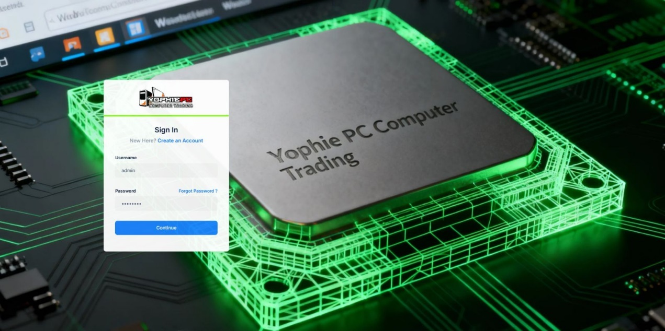
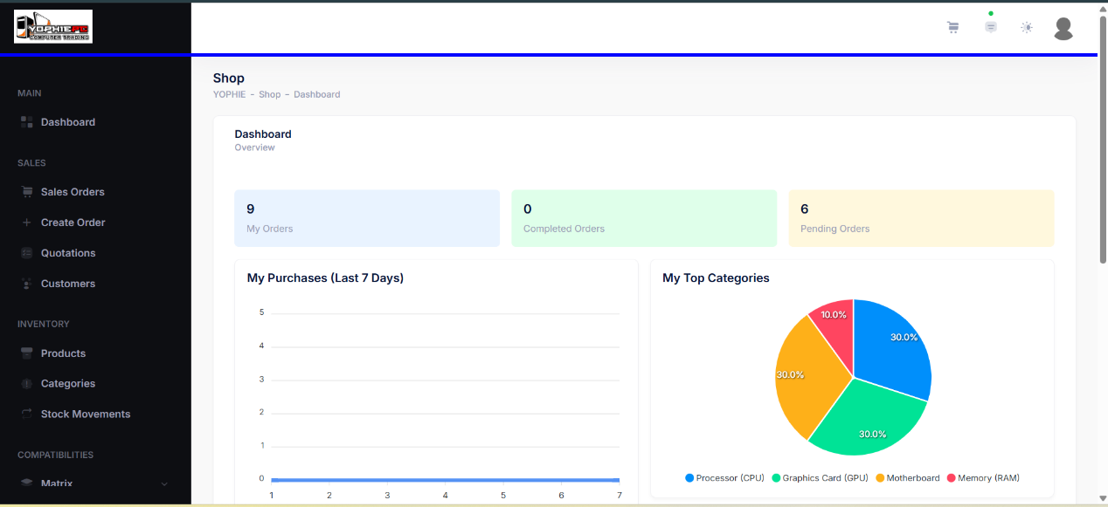
The figure shows the Sign In page of the Yophie PC Computer Trading system, where users enter their username and password to access the platform, with options to create an account or recover a password.

The figure shows the Shop Dashboard of the Yophie PC Computer Trading system, featuring a sidebar menu and summary cards for orders (my orders, completed, pending), along with analytics such as recent purchases and a top categories pie chart.

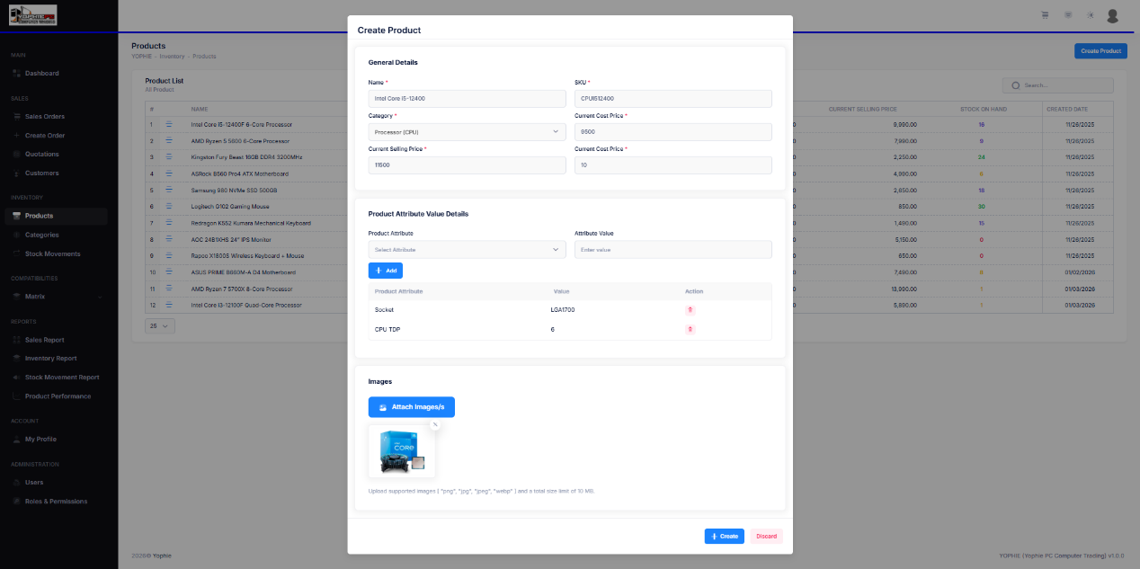
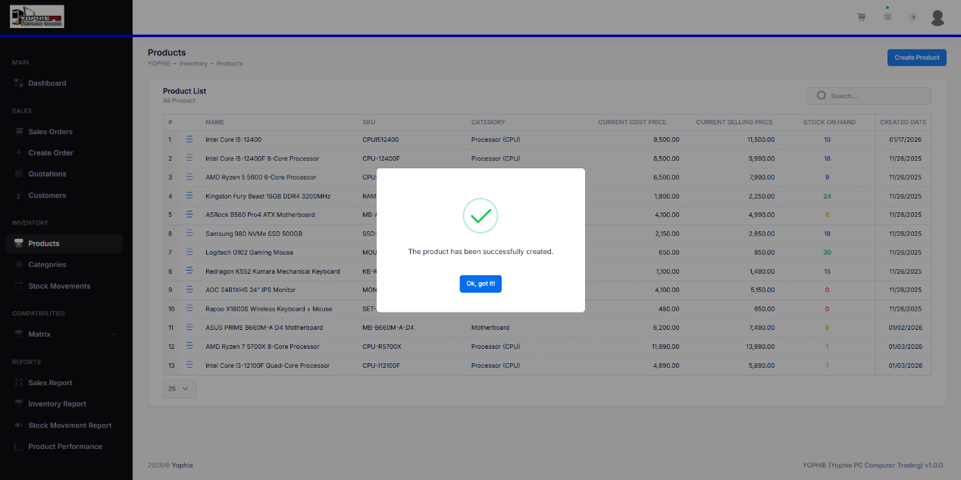
The figure shows the Create Product module of the system, where users can add a new product by entering general details (name, SKU, category, pricing), assigning product attribute values, and uploading product images before saving the record.

The figure shows a success confirmation message indicating that the product has been successfully created in the system, displayed over the Products list page.
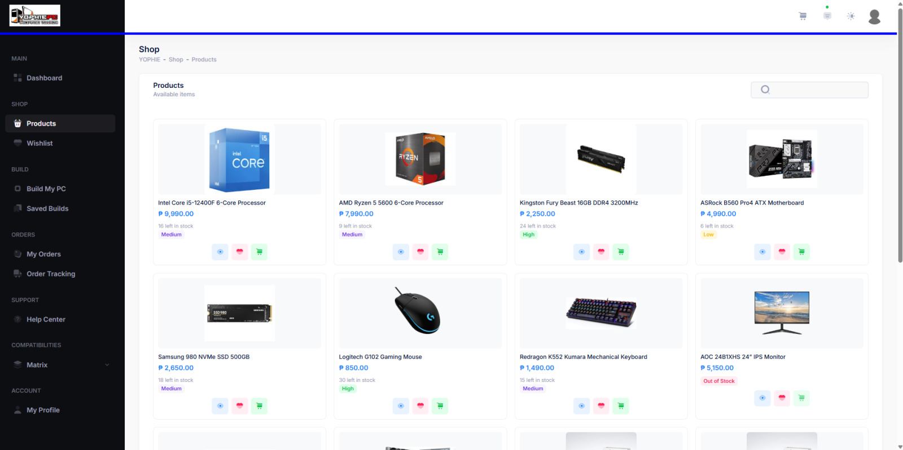

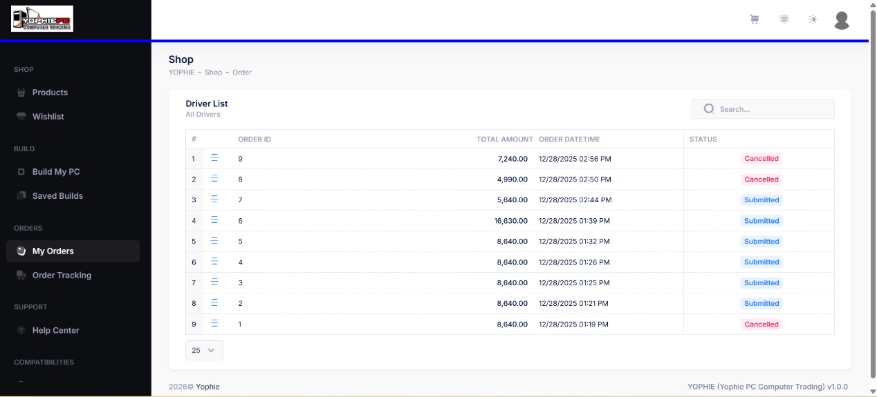
The figure shows the Products page of the Shop module, displaying available computer components in a card layout with product images, names, prices, stock status, and quick action buttons for viewing details, adding to wishlist, or adding items to a build.

The figure shows the My Orders page of the Shop module, listing customer orders with details such as order ID, total amount, order date/time, and order status (e.g., submitted or cancelled).

APPENDIX
B

Figures

Conceptual Framework

System Architecture

System Flow Chart

Figure 11. System Flowchart for Administrator

Figure 12. System Flowchart for Staff

Figure 13. System Flowchart for User
Used Case Diagram

Figure 14. Administrator Use Case Diagram

Figure 15. Staff Use Case Diagram

Figure 16. User Use Case Diagram

APPENDIX
C

Source Code

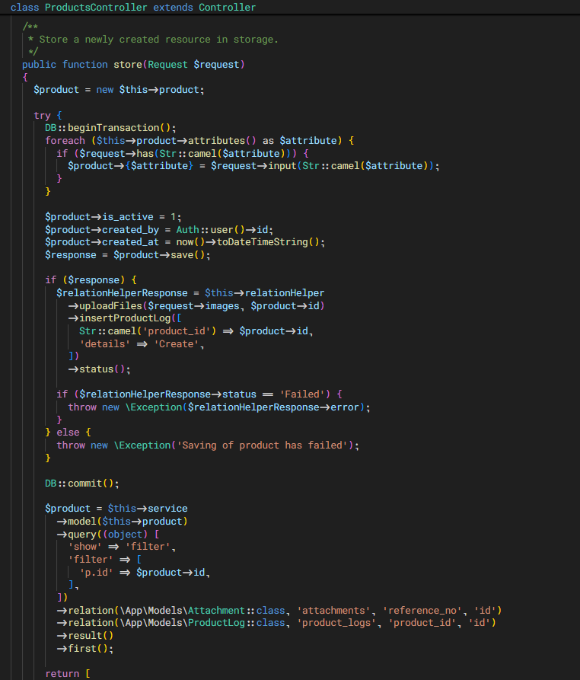

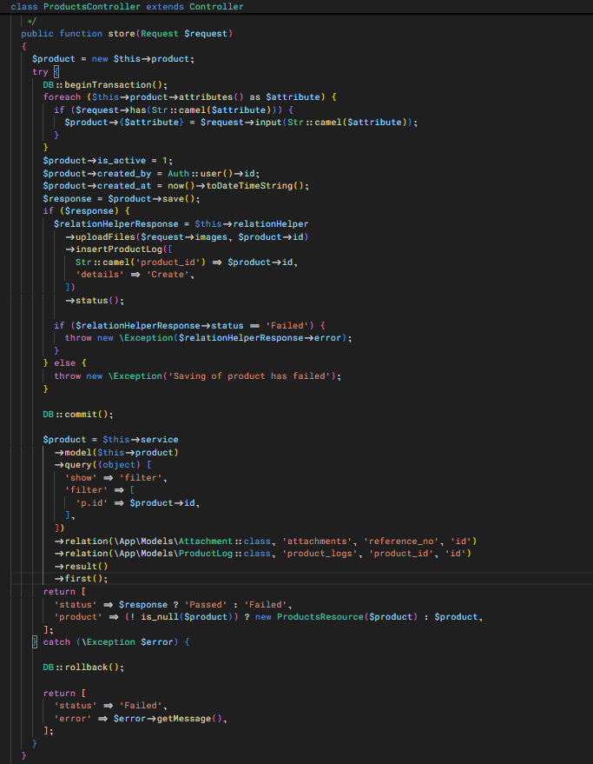

APPENDIX
D

Communications Letter & Approvals



Republic of the Philippines
Laguna State Polytechnic University
Province of Laguna

November 28, 2025
Mr. and Mrs. Limpiada
Yophie Pc Computer Trading
Calamba, Laguna
Dear Mr. and Mrs. Limpiada,
Good day.
I am a Bachelor of Science in Information Technology student from Laguna State Polytechnic University – Los Baños Campus. I am currently conducting my capstone research entitled “Retail Management Platform with Intelligent Stock Monitoring and Personalized Product Recommendation System for Yophie PC Computer Trading.”
In line with this, I respectfully request your permission to gather relevant information, observations, and insights related to retail operations at Yophie PC Computer Trading in Calamba City, Laguna. The study focuses on developing and evaluating a system that automates inventory monitoring and provides personalized, compatibility-based product recommendations to improve operational efficiency and customer experience.
Your experience and knowledge in managing computer hardware retail operations would greatly contribute to the credibility and success of this research. Insights from your actual business processes will help ensure that the developed system addresses real-world challenges in inventory management, stock accuracy, and product selection.
Rest assured that all information gathered will be used strictly for academic purposes only and will be treated with utmost confidentiality.

Thank you very much for your time and support. God bless.
Respectfully yours,

Samson G Abnay
BS in Information Technology
Laguna State Polytechnic University – Los Baños Campus


Noted by:
JOCELYN O. PADALLAN, MIT
Research Adviser
Laguna State Polytechnic University – Los Baños Campus

APPROVAL SHEET

The The Capstone Project entitled “RETAIL MANAGEMENT PLATFORM WITH INTELLIGENT STOCK MONITORING AND PERSONALIZED PRODUCT RECOMMENDATION SYSTEM FOR YOPHIE PC COMPUTER TRADING”, prepared and submitted by Samson G. Abnay in partial fulfillment of the requirements for the degree Bachelor of Science in Information Technology specialized in Service Management Program, is hereby recommended for approval and acceptance.

JOCELYN O. PADALLAN
Adviser

Approved and Accepted by the Committee on Oral Examination with a grade of _______.

MYRA V. PAICAGLINO SHERWIN B. SAPIN
Member Member

JEFFERSON L. LERIOS
Member

Accepted as partial fulfillment of the requirements for the degree of Bachelor of Science in Information Technology specialized in Service Management Program.

LOYD S. ECHALAR, DIT
Associate Dean, College of Computer Studies

OFELIA B. MANINGAS, Ed. D. ___________
Chairperson, Research and Development Services Date Signed

RESEARCH CONTRIBUTION NO.
SYSTEM EVALUATION USING ISO/EIC 25010 QUALITY MODEL
This study aims to develop the RETAIL MANAGEMENT PLATFORM WITH INTELLIGENT STOCK MONITORING AND PERSONALIZED PRODUCT RECOMMENDATION SYSTEM FOR YOPHIE PC COMPUTER TRADING. Rest assured that any information provided will be treated with the utmost confidentiality and used solely for the purpose of this research. Thank you for your valuable cooperation and support.
EVALUATED BY: ______________________________ DATE: _____________
FIELD OF SPECIALIZATION: _____________________________
POSITION: ___________________________
INSTRUCTION: Rate your level of satisfaction with the characteristics of the system by using the following scale.
Strongly Disagree | Disagree | Agree | Strongly Agree
1 | 2 | 3 | 4

Characteristics | Guide Context | 1 | 2 | 3 | 4
I. Functionality Suitability
Completeness | The system covers all essential retail operations, including real-time stock monitoring, product management, transaction recording, and personalized product recommendations.
Correctness | The system provides accurate inventory data, correct product details, and reliable compatibility-based recommendations for computer hardware components.
Appropriateness | The system effectively supports retail tasks such as inventory tracking, product browsing, and decision-making, enabling users to accomplish their objectives efficiently.
II. Reliability
Maturity | The system operates consistently during regular use, with minimal errors encountered during testing and deployment.
Availability | The platform remains accessible to users during business hours, allowing continuous monitoring of stock levels and transactions.
Fault Tolerance | The system handles minor errors, such as invalid inputs or connection issues, without disrupting overall operations.
Recoverability | In the event of system interruption, data is preserved and operations can resume without loss of critical inventory or transaction records.
III. Performance Efficiency
Response Time | The system responds quickly to user actions, including product searches, stock updates, and recommendation generation.
Throughput | The platform supports multiple users simultaneously without noticeable performance degradation.
Resource Utilization | System resources such as memory and processing power are efficiently utilized to maintain stable performance.
Scalability | The system can accommodate increasing numbers of products, transactions, and users as the business grows.
Load Handling | The platform performs reliably even during peak usage periods, such as high transaction volumes or multiple concurrent searches.
IV. Operability
Appropriateness Recognizability | Users can easily determine that the system is suitable for managing retail operations.
Learnability | New users can learn how to use the system with minimal training.
Operability | The system can be operated smoothly with minimal effort from administrators, staff, and customers.
User error protection | The system helps prevent common user errors, such as invalid stock updates or incorrect product entries.
User interface aesthetics | The interface provides a clean, organized, and visually appealing layout that enhances user experience.
Accessibility | The system allows users to accomplish tasks efficiently across supported devices.
V. Security
Confidentiality | User accounts, inventory data, and transaction records are accessible only to authorized users.
Integrity | The system protects data from unauthorized modification and maintains the accuracy of inventory and transaction information.
VI. Compatibility
Co-existence | The system operates alongside existing software and tools used by the business without conflict.
Interoperability | The platform communicates effectively between the frontend (Vue 3), backend (Laravel 10), and the MySQL database.
VII. Maintainability
Modularity | The system is composed of separate modules (inventory, product management, recommendations, users), allowing updates without affecting other components.
Reusability | System components can be reused or extended for future enhancements or similar retail applications.
Analyzability | System errors and performance issues can be identified and diagnosed quickly.
Modifiability | The system can be efficiently updated to accommodate new features or changes in business requirements.
Testability | Clear test criteria are established, allowing the system to be tested effectively before deployment.

Comments and Suggestions:
_______________________________________________________________________________________________________________________________________________________________________________________________________________

Part 1: Respondents Data
Directions: Please fill in the following information
Name of the Respondents (optional): ________________________
Position: __________________

Age: ________________________ Education: __________________

Level Proficiency
Level 1 - Fundamental Skills (Typing, Mouse)
Level 2 - Basic Computing and Applications.
Level 3 - Intermediate Computing and Applications.
Level 4 - Advanced Computing and Applications.
Level 5 - Proficient Computing, Applications, and Programming.

Technology Acceptance Questionnaire

Dear Respondents,
Greetings!
The purpose of this questionnaire is to evaluate user acceptance and behavioral intention toward using the Retail Management Platform with Intelligent Stock Monitoring and Personalized Product Recommendation System developed for Yophie PC Computer Trading in Calamba City, Laguna. The system is designed to improve retail operations by providing real-time inventory tracking, automated stock updates, compatibility-based product recommendations, and an integrated dashboard for administrators, staff, and customers.
This questionnaire consists of two parts. The first part gathers respondent information, while the second part assesses the system’s usability, usefulness, efficiency, reliability, and overall acceptance based on the Technology Acceptance Model (TAM).
Your participation is greatly appreciated. Rest assured that all responses will be treated with confidentiality and will be used solely for academic purposes.
Thank you very much for your time and cooperation.

Sincerely,
Samson G. Abnay

Part 2: Technology Acceptance Questionnaire
Directions: Kindly put CHECK ( ) on the corresponding scale to indicate your level of acceptance relative to each question. Indicate your acceptability with the following statement using the following scale:
1 – Strongly Disagree, 2 – Disagree, 3 – Agree, 4 – Strongly Agree

You may also indicate your comment and suggestions at the last part of the questionnaire.
QUALITY FACTORS | 1 | 2 | 3 | 4
- Correctness: The system provides accurate and up-to-date inventory information.
- Reliability: The system performs consistently during daily retail operations.
- Efficiency: The system helps complete retail tasks faster, such as stock checking and product selection.
- Integrity: User accounts are properly protected through authentication and access control.
PERCEIVE EASE OF USE | 1 | 2 | 3 | 4
- Learnability: The system is easy to learn, even for first-time users.
- Understandability: The system’s flow and functions are clear and easy to understand.
- Operability: The system reduces effort in managing inventory, products, and transactions.
- Attractiveness: The system interface is visually appealing and user-friendly.
PERCEIVED USEFULNESS | 1 | 2 | 3 | 4
- Operability: Using the system improves my efficiency in performing retail-related tasks.
- Usability: The automated stock monitoring helps prevent inventory discrepancies.
- Efficiency: The personalized product recommendation feature helps customers choose compatible products more easily.
- Functional Completeness: The system improves overall store operations.
ATTITUDE TOWARDS USING | 1 | 2 | 3 | 4
- The system saves time and effort in managing retail activities.
- The system improves decision-making for inventory and product selection.
- I find the system beneficial for daily retail operations.
- I feel confident and satisfied using the system as part of regular retail management tasks.
BEHAVIORAL INTENTION TO USE | 1 | 2 | 3 | 4
- I am willing to use this system regularly.
- I am willing to recommend this system to others.
- I am willing to continue using the system if implemented permanently.
- I am open to participating in future system improvements.
EXPERIENCE | 1 | 2 | 3 | 4
- I can easily navigate and use the system for my assigned tasks.
- I rarely experience errors while using the system.
- The system makes retail operations smoother and more convenient.
- The system enhances the overall shopping and management experience.
Feel free to write a comment if you have any suggestion or recommendations. Please state it here:
__________________________________________________________________________________
__________________________________________________________________________________
__________________________________________________________________________________

Evaluated by:

Respondents

APPENDIX
E

Plagiarism Result

APPENDIX
F

Curriculum Vitae



APPENDIX
G

Documentation

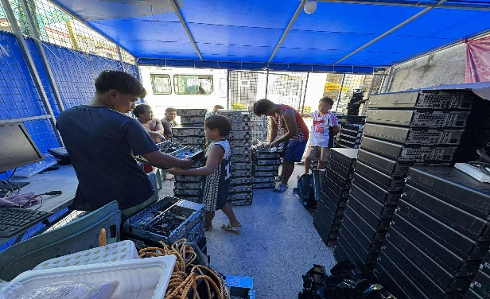

Owner of the Yophie PC Survey with the Yophie PC client

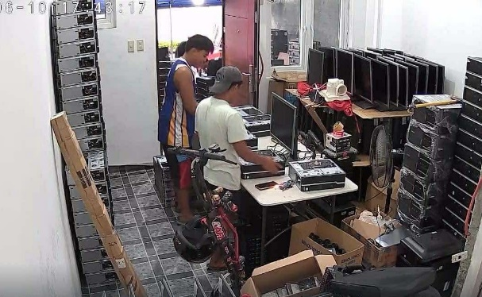

Survey with the Staff Survey with the I.T Specialist

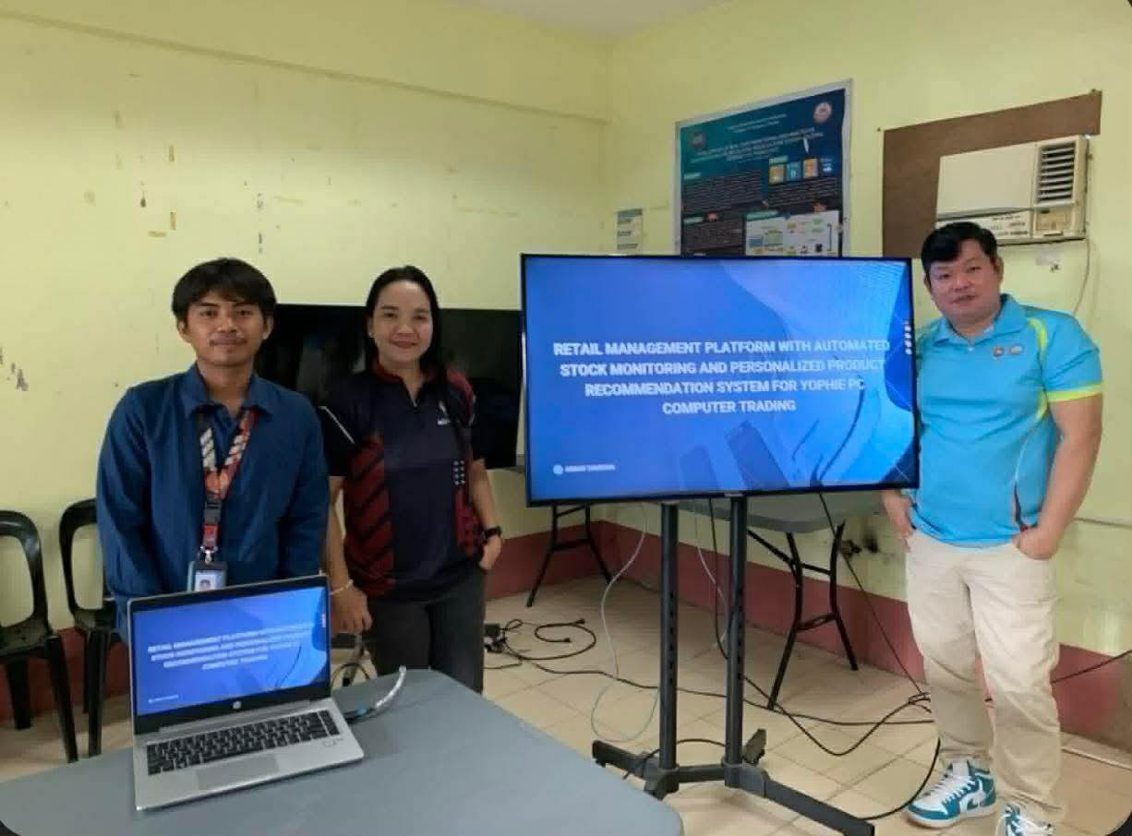
Defense

APPENDIX
H

Publishable Paper

